BIBIANI ANHWIASO BEKWAI MUNICIPAL ASSEMBLY
INTER OFFICE MEMO

TO: MUNICIPAL COORDINATING DIRECTOR
FROM: MUNICIPAL DEVELOPMENT PLANNING OFFICER
DATE: 27TH NOVEMBER 2025
SUBJECT: REPORT ON THE NUTRITION PRGRAMMES IMPLEMENTED FOR YEAR 2025

I kindly submit the above report for your consideration and further action, please.
Thank you.

Douglas Danso

BIBIANI-ANHWIASO-BEKWAI MUNICIPAL HEALTH DIRECTORATE
NUTRITION PRGRAMMES IMPLEMENTED IN THE MUNICIPALITY FOR YEAR 2025
- UNDER FIVE CHILD WELFARE CLINICS
This is a service that is being rendered at the various health facilities and community level by health workers to monitor the growth and health status of babies from Day 1 to five years of the child year. Monthly sensitization programmes were held on both radio band communities to reduce infant and adult malnutrition in the municipality. This service helps to track the feeding status and nutritional status, health education for nursing mothers, vaccination of the child when due for immunization against a particular disease, vitamin A supplementation and as well as child registration.
- MATERNAL NUTRITION
Maternal nutrition refers to the nutritional needs of women prior to conception and during antenatal and postnatal care period and this considers nutrition before pregnancy, during pregnancy, whiles breastfeeding and all of these when practiced well help reduce both maternal and infant morbidity and mortality. These interventions are meant to promote healthy pregnancies, reduce risk of birth complications, infants’ health prevention from micronutrients and improve maternal health in the municipality.
- START RIGHT FEED RIGHT
This is an infant and young child feeding campaign that starts from birth up to 2 years of child age and this campaign aims at increasing early initiation of breastfeeding within one hour after delivery, increase exclusive breastfeeding at six months and increase the percentage of children fed the minimum acceptable diet. By addressing nutrition during the critical early years of life, the "Start Right, Feed Right" program can have far-reaching positive effects on individual children, families, communities, and the nation, contributing to a healthier and more prosperous future for Ghana.
- GIFTS (GIRLS’ IRON-FOLATE SUPPLEMENTATION)
This programme is a public health intervention designed to provide adolescent girls with weekly iron and folic acid tablets free of charge to help prevent anemia because this intervention aims to provide once weekly iron and folic acid supplement in both in school and out of school adolescent girls.

- NFSI (NUTRITION FRIENDLY SCHOOLS INITIATION)
NFSI is an initiative implementation which incorporates interventions such as the intake of fruits and vegetables days by the school children, health inspection days, general cleaning of school compounds, physical activities day, Girls’ Iron and Folic Acid table supplement, nutrition education.
- DIETARY RELATED DISEASE CLINICS
This is a service that focuses on giving health education and support on emerging non-communicable diseases such as hypertension, stroke, and diabetes. Incorporating dietary-related disease clinics into the healthcare system in the municipality can lead to positive health outcomes, improved patient engagement, and a stronger focus on preventative care, ultimately contributing to healthier communities and reduced burden on healthcare resources.
STRATEGIES USED FOR THE IMPLEMENTATION
- Radio program was held every Saturday morning on local FM station in Bibiani and Sefwi Bekwai on nutrition and public health related issues targeted at improving the quality of nutritional status of the populace.
- Nutrition education for aggregate groups during routine service such as Child Welfare Clinic, ANC and PNC etc.
- In partnership with Care Ghana, NCCE, Municipal Environmental and Sanitation Unit, Municipal Education Directorate and local FM station will carry out sensitization activities in communities and public areas on nutrition through food demonstrations.
- Collaboration with Municipal Assembly to coordinate GIFTS activities in school.
- Involved community members from the outset to gain their insights and build trust. Community leaders, local influencers, and traditional authorities played a pivotal role in advocating for and supporting the program.
- Adapt program materials and messages to align with local cultural norms and values. Respectful integration of traditional practices and beliefs can enhance acceptance and engagement.
- Organize workshops, seminars, and community meetings to provide hands-on nutrition education, cooking demonstrations, and interactive sessions that encourage active participation.

Specific Nutrition Interventions implemented in 2025
SN | ACTIVITY | TARGET GROUP | BENEFICIARIES
1. | UNDER FIVE (5) CHILD WELFARE CLINICS AND CHPS | All children under 5 years within the Municipal | 40,307
2 | MATERNAL NUTRITION | All Reproductive women especially pregnant and Nursing mothers | 33,589
3 | START RIGHT FEED RIGHT | Babies from Birth to 2years | 13,436
4 | GIFTS (GIRLS IRON – FOLATE SUPPLEMMENTATION) | Adolescent age 10-19 years | 8,000
5 | NFSI (NUTRITION FRIENDLY SCHOOLS INITIATION | Some selected schools and children | 1,351
6. | SENSITIZATION TO REDUCE INFANTS, ADULT MALNUTRITION, AND DIETARY NON-COMMUNICABLE DISEASES | All aged and vulnerable people, especially all diabetic and hypertensive patients etc. | 7,000
7 | PROMOTE NUTRITIONALLY SENSITIVE AND COST-EFFECTIVE DIET THROUGH EDUCATION AND SENSITIZATIONS ON RADIO AND COMMUNITY VISITS | All nutritionally dense food items especially the locally produced foods and vegetables | 6,000
8 | PROMOTE THE PRODUCTION OF DIVERSE, NUTRIENT-RICH FOOD AND CONSUMPTION OF NUTRITIONAL FOODS | All ages especially women, children, and youth | 2,000
9 | ORGANIZE DEMONSTRATIVE TRAINING WORKSHOP FOR WOMEN ON KITCHEN GARDENS AND FOOD BASAL IN 10 COMMUNITIES | Identified communities identified as high-risk areas for malnutrition in the municipality | 3,500
Source: BABMA - MHD - 2025
CONCLUSION
Bibiani-Anhwiaso-Bekwai Municipal Health Directorate made notable progress in promoting nutrition, preventing malnutrition, and improving the health and well-being of children, women, adolescents, and vulnerable groups for the year 2025. Through targeted planned activities such as Child Welfare Clinics, Maternal Nutrition services, Start Right Feed Right, GIFTS, and Nutrition Friendly Schools Initiatives, the municipality strengthened preventive care and improved awareness on proper nutrition practices. Dietary-related disease clinics and community sensitizations also contributed significantly to tackling the growing burden of non-communicable diseases. These achievements were realized through collaboration with the Municipal Assembly, development partners, community engagement, radio advocacy, and school-based nutrition education. In conclusion, the implementation of these nutrition programmes has improved health outcomes and laid a solid foundation for a healthier and more nutrition-conscious municipality.
RECOMMENDATIONS FOR FURTHER ACTIONS
- Expansion of the Start Right Feed Right programme, kitchen garden training, and food demonstration activities to more communities to increase coverage and impact, especially in rural and high-risk malnutrition zones.
- Increased the number of schools benefitting from NFSI and intensify supervision to ensure consistent practice of fruit and vegetable intake, physical activities, and hygiene checks.
- Expand the GIFTS programme to cover all junior and senior high schools, including out-of-school adolescents, to reduce anemia prevalence among girls.
- Provision more targeted counselling, micronutrient supplementation, and follow-up support for pregnant and nursing mothers to reduce maternal and infant complications related to poor nutrition.
- Strengthening of clinics by providing nutrition counsellors, dieticians, and adequate logistics to improve management and prevention of non-communicable diseases like hypertension and diabetes.
- The Municipal Assembly, NGOs, private sector actors, and development partners should continue and increase support for nutrition activities, including funding for logistics, community sensitization, and school health programmes.
- Continue and expand radio programmes and community sensitizations on healthy eating, food safety, and nutrition to ensure sustained behavioural change among households.
The above recommendations, if implemented, will further enhance nutrition outcomes, reduce malnutrition and nutrition-related diseases, and contribute to a healthier and more productive Bibiani-Anhwiaso-Bekwai Municipality.
COMPILED BY: VERIFIED BY:
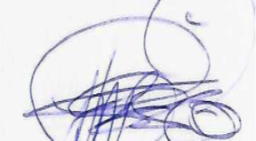
DOUGLAS DANSO BOFFOUR AHMED HARUNA
MUNICIPAL PLANNING OFFICER MUNICIPAL COORDINATING DIRECTOR

PICTURE GALLARY FOR ACTIVTIES IMPLEMENTED
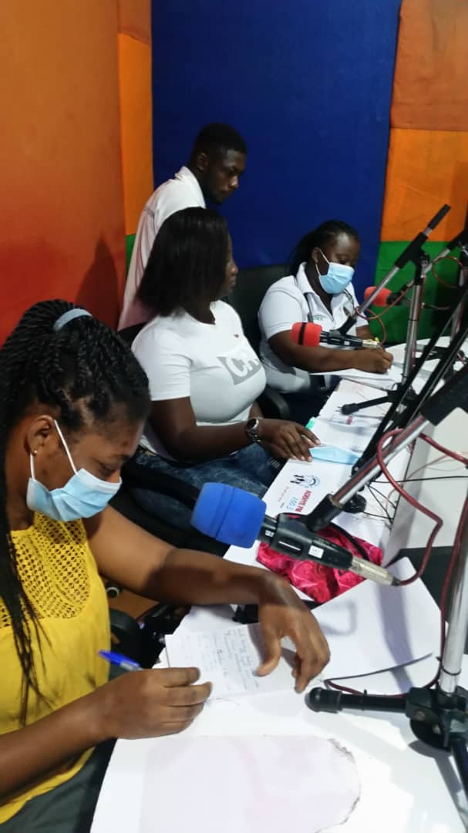
RADIO TALK SHOW PROGRAM WITH A LOCAL FM STATION (ADEHYE FM STATION)
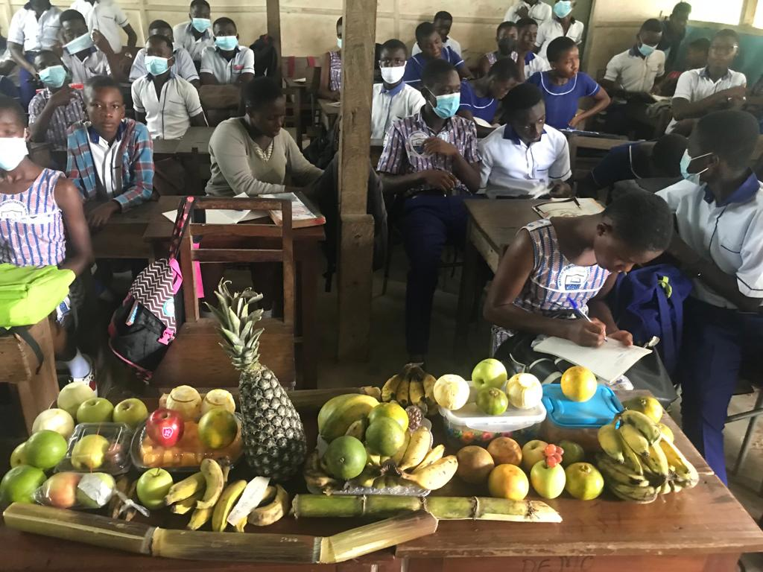
NUTRITION FRIENDLY SCHOOL INITIATIVE – FRUIT DAY AT SCHOOL
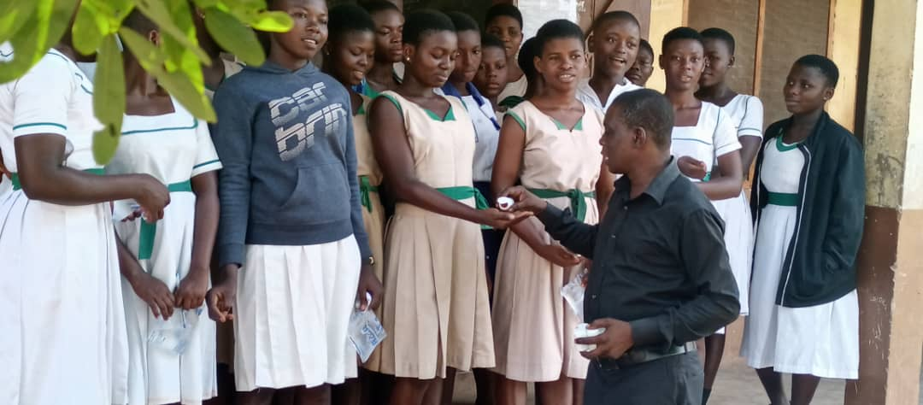
GIRLS IRON FOLATE TABLET SUPPLEMENTATION (GIFTS) – IN SCHOOL GIFTS
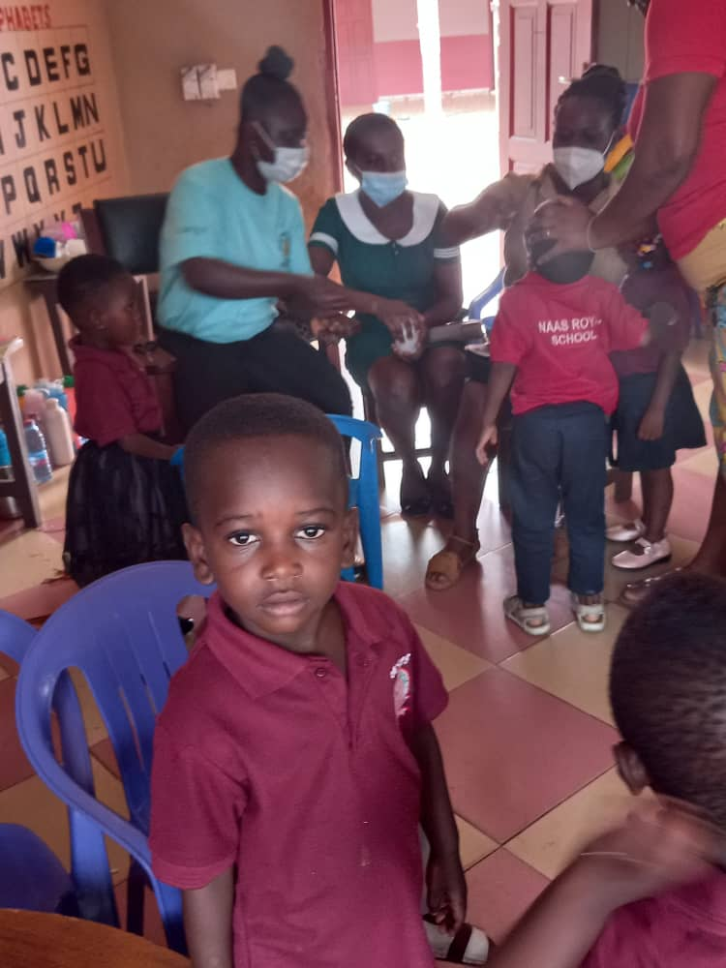
SCHOOL HEALTH AND SCREENING SERVICE
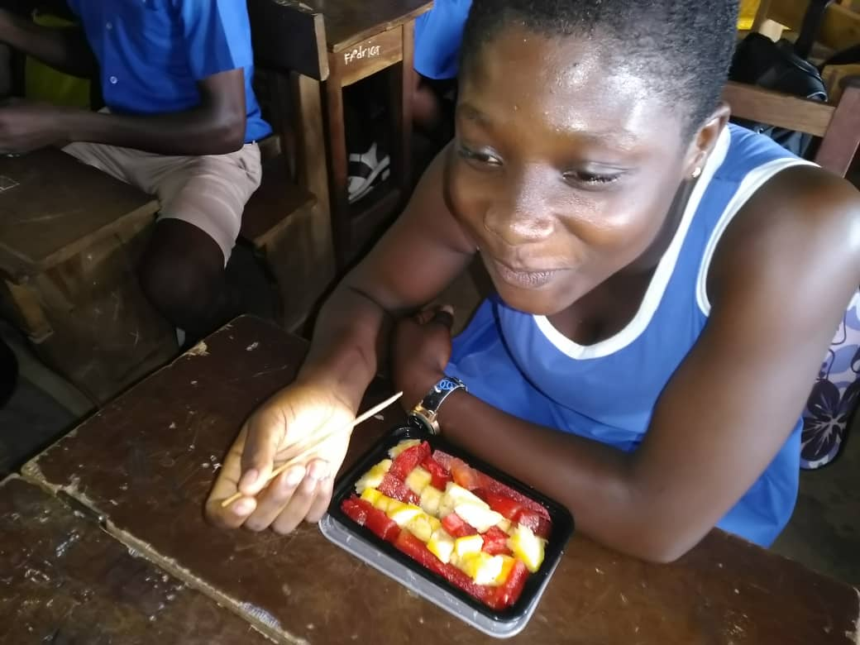
FRUIT DAY AT SCHOOL – NUTRITION FRIENDLY SCHOOL INITIATIVE
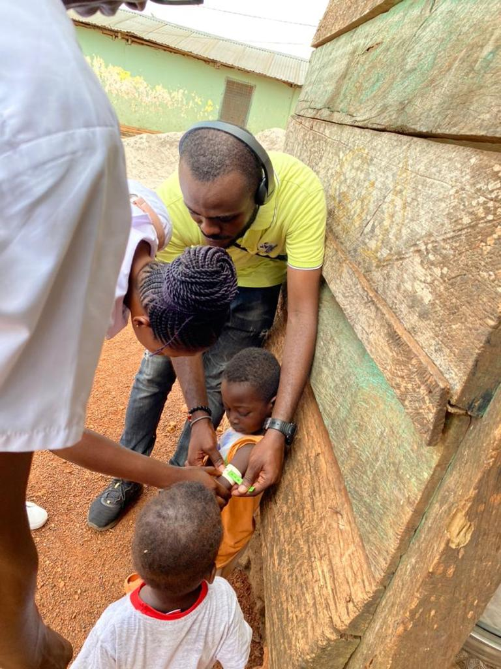
NURSES CARRYING OUT HOME VISITS AND SCREENING OF CHILDREN TO ASSESS THEIR NUTRITION STATUS
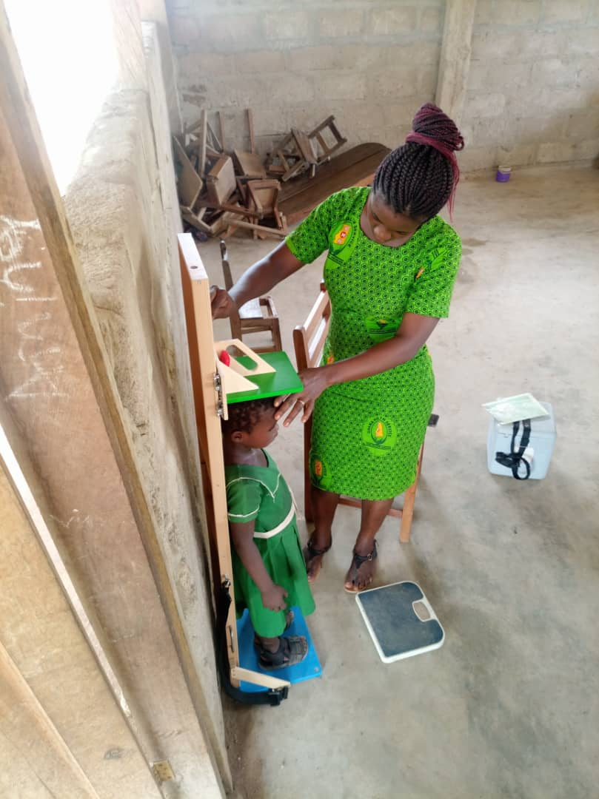
SCHOOL HEALTH – ASSESSING HEIGHT/LENGTH OF SCHOOL CHILDREN
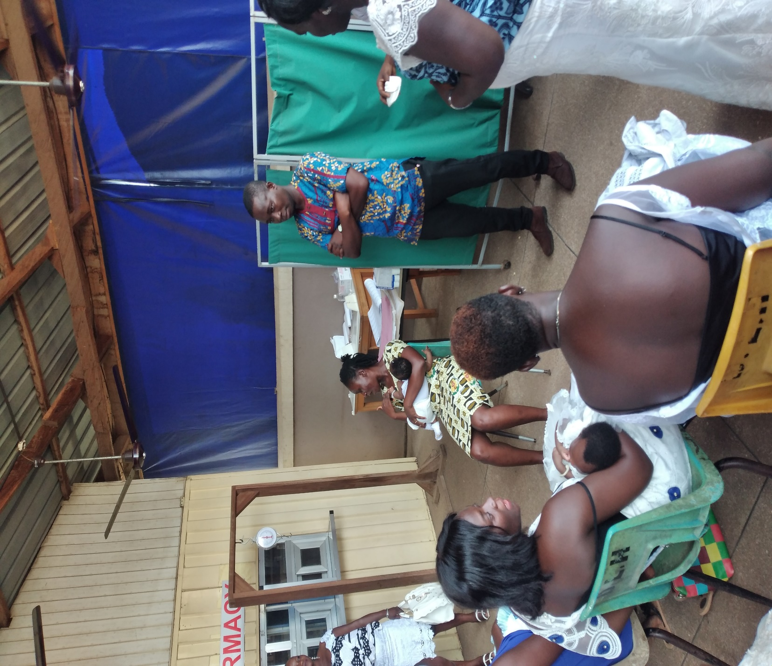
CHILD WELFARE CLINIC (CWC) – EDUCATING LACTATING MOTHERS ON HOW TO POSITION CHILDREN TO BREASTFEED PROPERLY

