Env’tal Health & Sanitation Unit
B A B M A
Post Office Box 49
11th April, 2023

FIRST QUARTER REPORT ON WASTE MANAGEMENT
Poor management of solid waste has become a national issue not only in Bibiani Anwhiaso Bekwai Municipality.
To obviate this menace, the Assembly contracted Zoomlion Ghana Limited to help the few aged Assembly sanitary labourers in this regard.
SWEEPING AND COLLECTION OF REFUSE
To ensure efficient and effective service delivery, the workers was scheduled to work in their respective areas.
The Assembly sanitary labourers worked at the towns and places below;
Bibiani - Market, new station and Lineso plantain market
Bekwai - Market and lorry station
On the other hand Zoomlion labourers work at the streets and other small communities in the Municipality.
TRANSFER STATIONS/CONTAINER SITES
Zoom lion Ghana Limited were the sole workers made to work at these places, however in case of any spillage of refuse on site, the Assembly sanitary labourers do assist in the evacuation work.
The table below indicates transfer stations and containers details
S/N | SUBURB | LOCATION | NUMBER OF CONTAINER
1 | Newtown | Charcoal Market | 1
2 | Compound (New ) | New Lorry Station | 1
3 | Estate | Near Mun,Education Office | 1
4 | Nantwikuye | Near Christ Apostolic Temple | 1
5 | Hwenampori | Near Church Of Pentecost Temple | 1
6 | Sefwi Bekwai Light House | Slaughter Slab | 2
7 | Sefwi Bekwai Low Cost | Jehova Witness Park | 2

Total number of containers in use were Nine (9)
Total number of transfer stations in use were nine (9)
EQUIPMENT AND LOGISTICS RECORDS
S/N | TYPE | TO BE SUPPLIED | QTY FUNCTIONING | NUM. BROKEN DOWN | SUPPLIED | DEFICIT | REMARK
1. | Skipper Refuse Truck | 2 | 1 | 1 | 2 | 1
2 | Communal Refuse Containers | 21 | 9 | 9 | 18 | 3
2 | Stir case | 21 | 0 | - | 0 | 0

- SANITATION SERVICE PROVIDERS
To improve on solid waste management activities, other service providers were on board to carry out door to door refuse collection and disposal in the two major towns in the Municipality that is Bibiani and Bekwai.
- QUARTERLY MENTAINANCE OF FINAL DISPOSAL SITES
The Municipality has two (2) main final disposal sites, one at Bibiani and other at Sefwi Bekwai.
The maintenance has been awarded to waste Land fill company limited, a sanitation company.
Quarterly maintenance was not carried out during the period .
DISINFECTION / DISINFESTATION
Quarterly disinfection and disinfestation were not carried out in the Municipality.
CHALLENGES
1. Inadequate communal refuse containers resulting to dumping elsewhere.
2. Inadequate supply of sanitary tools and logistics to Assembly sanitary labourers and Environmental Health Officers.
3. Inadequate means of transport to monitor sanitation services in the municipality.
4. Lack of communal containers stir case.
5. Broken down a skip truck affecting work.
RECOMMENDATIONS
- Zoom lion advice to provide adequate communal refuse containers
- Adequate tools and logistics be provided to Assembly sanitary labourers and Environmental Health Officers
- Assembly provide adequate means of transport for Environmental Health Unit to monitor sanitation services.
- Zoomlion advice to provide stir case at all container sites.
- Zoomlion advice to repair breakdown skip truck

CONCLUSION
If the above recommendations are adhere to and implemented, sanitation service delivery in the Municipality will improve and the health of the people will improve same.

BEFORE PUSHING, LEVELLING, COMPACTING AND ROUND WAY OF REFUSE TRUCKS - BIBIANI

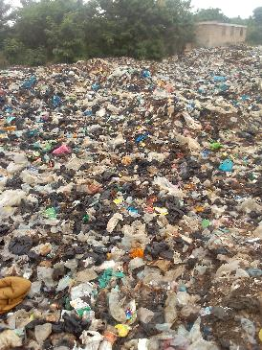
DURING PUSHING, LEVELLING, COMPACTING AND ROUND WAY OF REFUSE TRUCKS - BIBIANI

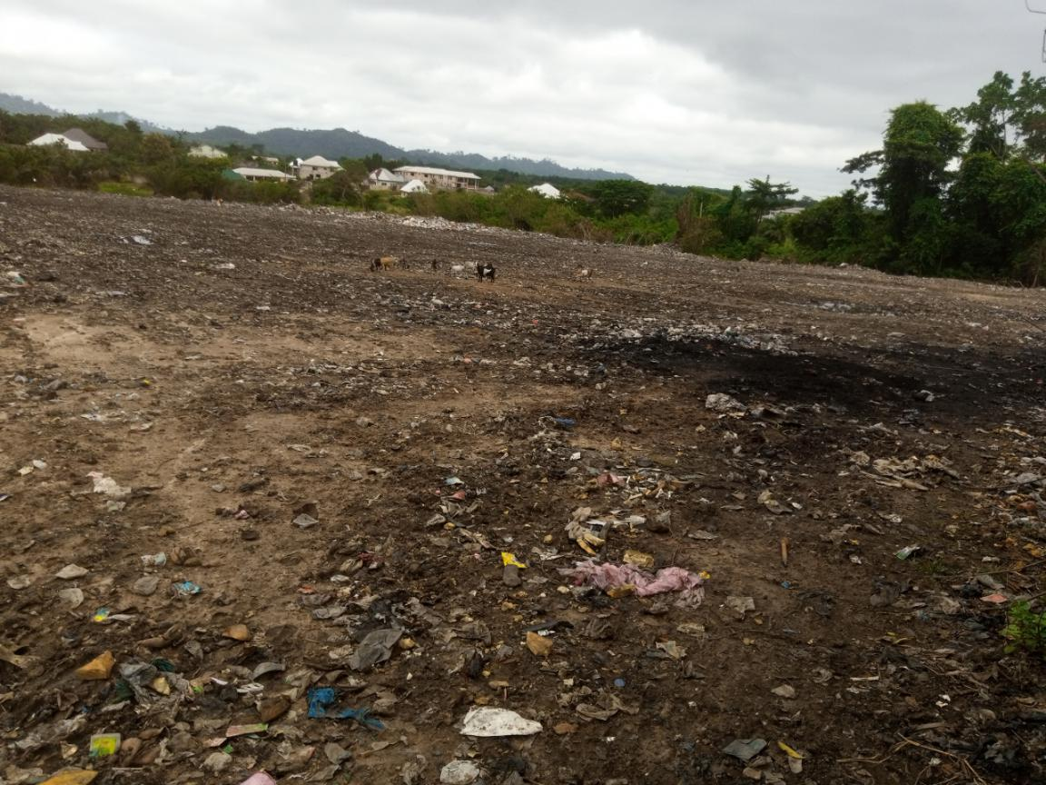

AFTER PSHING OF THE FINAL DISPOSAL SITE AT BIBIANI


