Env’tal Health & Sanitation Unit
B A B M A
Post Office Box 49
7th July, 2023

SECOND QUARTER MONITORING REPORT ON WASTE MANAGEMENT
Poor management of solid/liquid waste has become a national issue not only in Bibiani Anwhiaso Bekwai Municipality.
To avert this menace, the Assembly contracted Zoomlion Ghana Limited and Waste Landfill Company Limited to help the few aged Assembly sanitary labourers in this regard.
SANITATION SERVICE PROVIDERS
Name of Environmental Sanitation Service provider(s) | Category of Service  provider | Expected output of  Service provider | Remarks
Zoom-Lion GH. Ltd. | SPI (Sweeping, Collection,  Storage and  Disposal of  solid waste) | To ensure clean  environment | Carried out  successfully
Waste Land Fills Company Limited | Management of Final Solid waste Disposal Sites | Maintain Final Solid Waste Disposal sites | Pushing and levelling was done
Zoom-Lion GH. Ltd. | Disinfestation and Fumigation | Desilting and disinfestation of public drains | Public drains were desilt and disinfested

- SOLID WASTE MANAGEMENT
SWEEPING AND COLLECTION OF REFUSE
To ensure efficient and effective service delivery, the workers were scheduled to work in their respective areas.
The Assembly sanitary labourers worked at the towns and places below;
Bibiani - Market, new station and Lineso plantain market
Bekwai - Market and lorry station
On the other hand Zoomlion labourers work at the streets and other small communities in the Municipality.
TRANSFER STATIONS/CONTAINER SITES
Zoom lion Ghana Limited were the sole workers made to work at these places, however in case of any spillage of refuse on site, the Assembly sanitary labourers do assist in the evacuation work.
The table below indicates transfer stations and containers details
S/N | SUBURB | LOCATION | NUMBER OF CONTAINER
1 | Newtown | Charcoal Market | 2
2 | Compound (New ) | New Lorry Station | 1
3 | Attakrom | Near Public Toilet | 1
4 | Estate | Near Mun,Education Office | 1
5 | Oldtown | Near Glamco | 1
6 | Praga | Near Public Toilet | 1
7 | Nantwikumye | Near Christ Apostolic Temple | 1
8 | Hwenampori | Near Church Of Pentecost Temple | 1
9 | Sefwi Bekwai Light House | Slaughter Slab | 1
10 | Sefwi Bekwai Fabewoso | Fabewoso | 1
11 | Lineso | Plantain Market | 1

Total number of containers in use - Ten (10)
Total number of transfer stations in use- Ten (10)

EQUIPMENT AND LOGISTICS RECORDS
S/N | TYPE | TO BE SUPPLIED | QTY FUNCTIONING | NUM. BROKEN DOWN | SUPPLIED | DEFICIT | REMARK
1. | Skipper Refuse Truck | 2 | 1 | 1 | 2 | 1
2 | Communal Refuse Containers | 21 | 10 | 9 | 19 | 2
2 | Stir case | 21 | 0 | - | 0 | 0

To improve on solid waste management activities, other service providers were on board to carry out door to door refuse collection and disposal in the two major towns in the Municipality that is Bibiani and Bekwai.
MENTAINANCE OF FINAL DISPOSAL SITES
The Municipality has two (2) main final disposal sites, one at Bibiani and other at Sefwi Bekwai.
Maintenance (Pushing and leveling)of the disposal sites were carried out during the period.
- LIQUID WASTE MANAGEMENT
Disinfestation and desilting of public drain were carried out in the Municipality.
Disludgement of septic tanks, construction of modern toilet facilities and soak away were supervised by the Unit.
CHALLENGES
1. Inadequate communal refuse containers resulting to dumping elsewhere.
2. Inadequate supply of sanitary tools and logistics to Assembly sanitary labourers and Environmental Health Officers.
3. Inadequate means of transport to monitor sanitation services in the municipality.
4. Lack of communal containers stir case.
5. Broken down a skip truck affecting work.
6. Irregular lifting of communal refuse containers resulting to refuse spillage at container sites.
RECOMMENDATIONS
- Zoom lion advice to provide adequate communal refuse containers
- Adequate tools and logistics be provided to Assembly sanitary labourers and Environmental Health Officers
- Assembly provide adequate means of transport for Environmental Health Unit to monitor sanitation services.
- Zoomlion advice to provide stir case at all container sites.
- Zoomlion advice to repair breakdown skip truck
- Zoomlion advice to lift communal refuse containers regularly to avoid spillages.
CONCLUSION
If the above recommendations are adhere to and implemented, sanitation service delivery in the Municipality will improve and the health of the people will improve same.

Below are pictorial evidence of the exercise

ZOOMLION WORKERS SWEEPING AT CONTAINER SITE
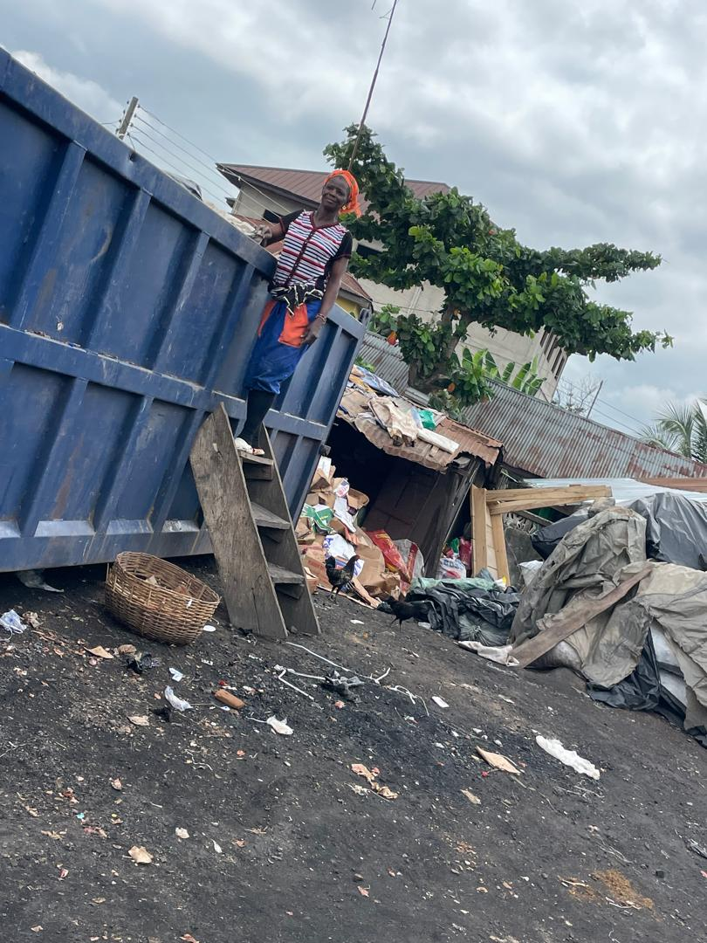

ZOOMLION WORKERS AT WORK


