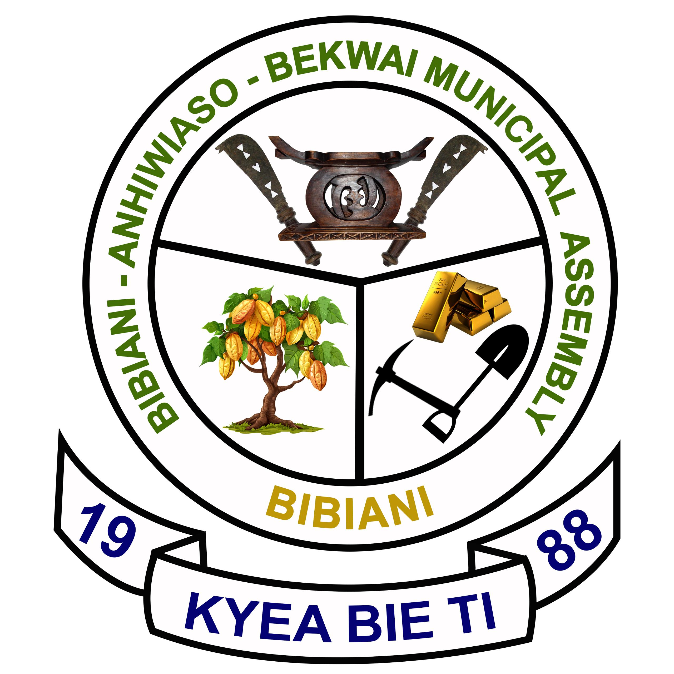 BI BIBIANI-ANHWIASO-BEKWAI

MUNICIPAL ASSEMBLY

In case of reply the
Number and Date of this
Letter should be quoted.

Our Ref. No: …………………………..

Your Ref: No.: …………………………….

P.O. BOX 49
BIBIANI
Western North Region
Tel.0531775543/0274325564

23th July, 2024

THE MUNICIPAL COORDINATING DIRECTOR/
MUNICIPAL CHIEF EXECUTIVE
B A B M A
BIBIANI

SUBMISSION OF 2024 SECOND QUARTER MONITORING REPORT ON SOLID/LIQUID WASTE MANAGEMENT

I submit here with 2024 2nd quarter report on Solid /liquid waste management exercise carried out in Bibiani Anhwiaso Bekwai Municipality by Zoom Lion Ghana Limited for your perusal and further action please.

CEPHAS K. DZAKAH
MUN. ENV’TAL HEALTH OFFICER
For: ( MUN. CHIEF EXECUTIVE)
Cc:
THE REGIONAL ENV’TAL HEALTH OFFICER
REGIONAL COORDINATING COUNCIL
SEFWI WIAWSO, WESTERN NORTH REGION

SECOND QUARTER MONITORING REPORT ON SOLID/LIQUID WASTE MANAGEMENT
Poor management of solid/liquid waste has become a national issue not only in Bibiani Anwhiaso Bekwai Municipality.
To avert this menace, the Assembly contracted Zoomlion Ghana Limited and Waste Landfill Company Limited to help the few aged Assembly sanitary labourers in this regard.
SANITATION SERVICE PROVIDERS
Name of Environmental Sanitation Service provider(s) | Category of Service  provider | Expected output of  Service provider | Remarks
Zoom-Lion GH. Ltd. | SIP (Sweeping, Collection,  Storage and  Disposal of  solid waste) | To ensure clean  environment | Carried out  successfully
Waste Land Fills Company Limited | Management of Final Solid waste Disposal Sites | Maintain Final Solid Waste Disposal sites | Pushing and levelling was done
Zoom-Lion GH. Ltd. | Disinfestation and Fumigation | Desilting and disinfestation of public drains | Public drains were desilt and disinfested

- SOLID WASTE MANAGEMENT
SWEEPING AND COLLECTION OF REFUSE
To ensure efficient and effective service delivery, the workers were scheduled to work in their respective areas.
The Assembly sanitary labourers worked at the towns and places below;
Bibiani - Market, new station and Lineso plantain market
Bekwai - Market and lorry station
On the other hand Zoomlion labourers work at the streets and other small communities in the Municipality.
TRANSFER STATIONS/CONTAINER SITES
Zoom lion Ghana Limited was the sole workers made to work at these places, however in case of any spillage of refuse on site, the Assembly sanitary labourers do assist in the evacuation work.
The table below indicates transfer stations and containers details
S/N | SUBURB | LOCATION | NUMBER OF CONTAINER
1 | Newtown | Charcoal Market | 2
2 | Compound (New ) | New Lorry Station | 1
3 | Attakrom | Near Public Toilet | 1
4 | Estate | Near Mun,Education Office | 1
5 | Oldtown | Near Glamco | 1
6 | Praga | Near Public Toilet | 1
7 | Nantwikumye | Near Christ Apostolic Temple | 1
8 | Hwenampori | Near Church Of Pentecost Temple | 1
9 | Sefwi Bekwai Light House | Slaughter Slab | 1
10 | Sefwi Bekwai Fabewoso | Fabewoso | 1
11 | Lineso | Plantain Market | 1

Total number of containers in use was Ten (10)
Total number of transfer stations in use was Ten (10)

EQUIPMENT AND LOGISTICS RECORDS
S/N | TYPE | TO BE SUPPLIED | QTY FUNCTIONING | NUM. BROKEN DOWN | SUPPLIED | DEFICIT | REMARK
1. | Skipper Refuse Truck | 2 | 1 | 1 | 2 | 1
2 | Communal Refuse Containers | 21 | 10 | 9 | 19 | 2
2 | Stir case | 21 | 0 | - | 0 | 0

To improve on solid waste management activities, other service providers were on board to carry out door to door refuse collection and disposal in the two major towns in the Municipality that is Bibiani and Bekwai.
MENTAINANCE OF WASTE LAND FILL SITE/FINAL DISPOSAL SITES
The Municipality currently has one Waste (1) Land Fill site
MAINTENANCE: Pushing and leveling of Waste Land fill site was carried out during the period.
PUSHING AND LEVELING OF OTHER REFUESE DUMPING SITES
Pushing and leveling of dumping sites of the following communities were carried out

Communities
1 Bibiani New Compound,
2. Adukrom
3. Anhwiaso
4. Bekwai Fabewoso

- LIQUID WASTE MANAGEMENT
Disinfestation and desilting of public drain were carried out in the Municipality.
Disludgement of septic tanks, construction of modern toilet facilities and soak away were supervised by the Unit.
CHALLENGES
1. Inadequate communal refuse containers resulting to dumping elsewhere.
2. Inadequate supply of sanitary tools and logistics to Assembly sanitary labourers and Environmental Health Officers.
3. Inadequate means of transport to monitor sanitation services in the municipality.
4. Lack of communal containers stir cases.
5. Broken down a skip truck affecting work.
6. Irregular lifting of communal refuse containers resulting to refuse spillage at container sites.
RECOMMENDATIONS
- Zoom lion GH LTD advice to provide adequate communal refuse containers
- Assembly provides adequate means of transport for monitoring Environmental Health and sanitation activities
- Zoomlion advice to provide stir case at all container sites.
- Zoomlion advice to repair breakdown skip truck
- Zoomlion advice to lift communal refuse containers regularly to avoid spillages.
CONCLUSION
If the above recommendations are adhered to and implemented, sanitation service delivery in the Municipality will improve as well as the health of the people.

Below are pictorial evidences of the work done

BEFORE THE EXERCISE AT NEW COMPUND REFUSE DUMP SITE

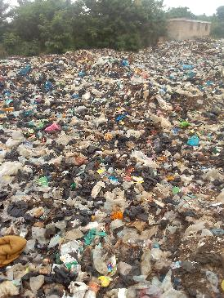

DURING THE EXECISE

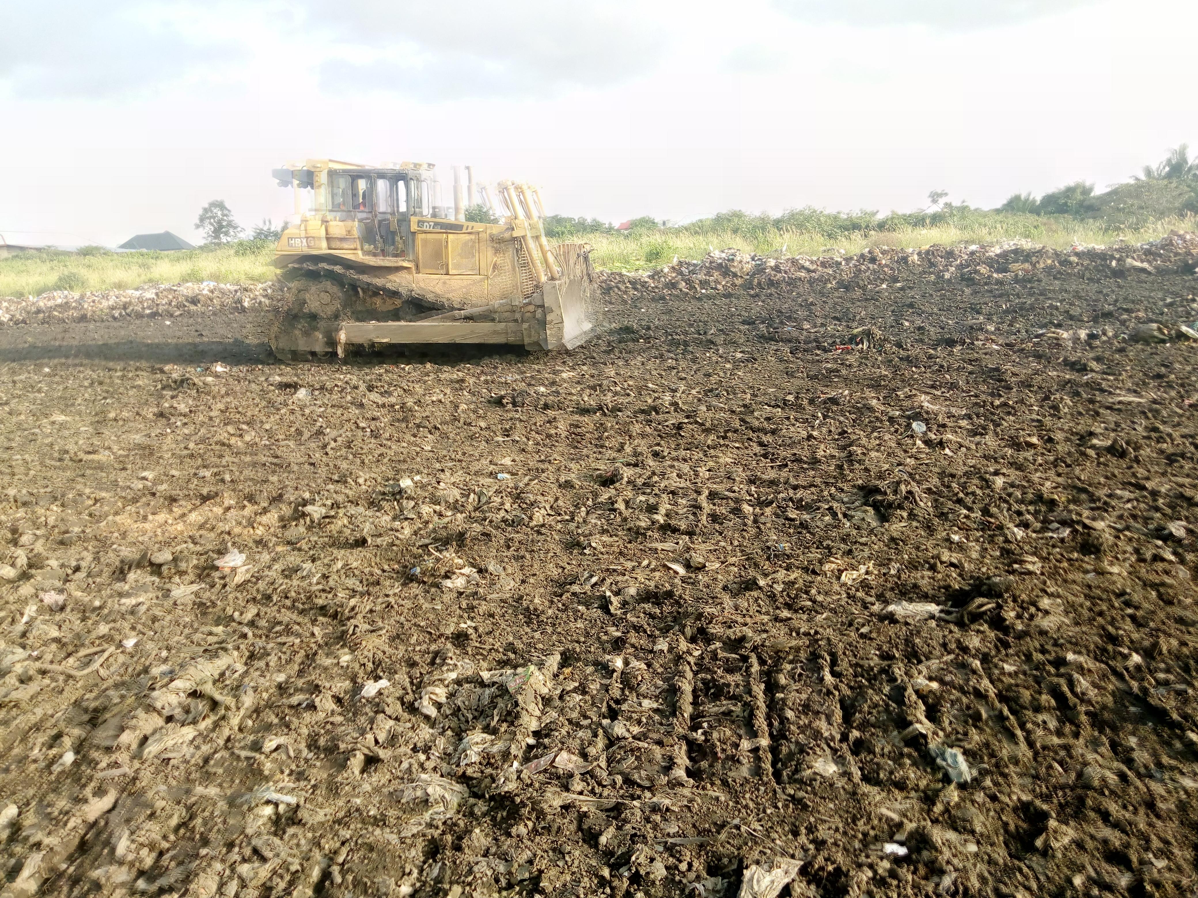

AFTER THE EXERCISE



