 BI BIBIANI-ANHWIASO-BEKWAI

MUNICIPAL ASSEMBLY

In case of reply the
Number and Date of this
Letter should be quoted.

Our Ref. No: …………………………..

Your Ref: No.: …………………………….

P.O. BOX 49
BIBIANI
Western North Region
Tel.0531775543/0274325564

2nd July, 2024

THE MUNICIPAL COORDINATING DIRECTOR/
MUNICIPAL CHIEF EXECUTIVE
B A B M A
BIBIANI

SUBMISSION OF SECOND QUARTER (APRIL – JUNE) 2024 REPORT
I submit here with 2024 second quarter activities report of Environmental Health and Sanitation Unit for your perusal and necessary action.

CEPHAS K. DZAKAH
MUN. ENV’TAL HEALTH OFFICER
For: ( MUN. CHIEF EXECUTIVE)
Cc:
THE REGIONAL ENV’TAL HEALTH OFFICER
REGIONAL COORDINATING COUNCIL
SEFWI WIAWSO, WESTERN NORTH REGION

BIBIANI ANHWIASO BEKWAI MUNICIPAL ASSEMBLY (B. A. B. M. A)

ENVIRONMENTAL HEALTH AND SANITATION UNIT
ACTIVITIES REPORT FOR
SECOND (2ND) QUARTER APRIL TO JUNE, 2024

TABLE OF CONTENT
MUNICIPAL PROFILE
EXECUTIVE SUMMARY
HUMAN RESOURCE/STAFFING
ENVIRONMENTAL PROTECTION STANDARDS AND ENFORCEMENT
Premises Inspection
Enforcement and Prosecution Management
Stray Animals Control
Pest and Vector Control and Other Entomological Activities
Waste Management
Disposal of The Dead
Environmental Monitoring
Monitoring of Environmental Sanitation Services
Building Sanitation
FOOD AND WATER HYGIENE
Market Sanitation
Sanitation of Food Establishments
Meat and Fish Hygiene
ENVIRONMENTAL HEALTH PROMOTION AND EDUCATION
School Health Activities
Community Mobilization
Public Relation and Complaints
Training and Skills Development
MISCELLANEOUS
Sustainable Development Goal (SDGS) Compliance Activities
Status of Government Priority Project or Programs
Revenue Mobilization
Inter-Agency Collaborative Activities
Logistics Stock
Overall Achievement
Work Plan for the rest of the Year
Challenges in Environmental Health and Sanitation Management in the Municipality
Recommendation
Conclusion
Appendix

PROFILE OF THE MUNICIPALITY

Items/Areas |  |  | Description
Data from Municipal Assembly

Vision | The vision is to be an efficient and effective Municipal with continuous enhancement of the living standard of its people.
Mission | The Assembly exists to facilitate the overall development of the Municipal by effective formulating and implementing plans and programme of the Assembly, Ministries ,Departments ,Agencies ,and Non-Governmental organizations in order to improve the quality of lives of the people in the Municipality.
Location | The Municipality is located between latitude 6° 3” N and longitude 2° 3” W. The Municipality is boarded to the north by the Atwima Mponua District in the Ashanti Region, South by the Wassa Amenfi in the Western Region, West by the Sefwi Wiawso Municipal Assembly in the Western Region and East by the Upper Denkyira West and Amansie Central in the Central Region and Ashanti regions respectively.
Land Size | The total land area of the Municipality is 833.7 km square. Bibiani is the Municipality capital.
Topography | The lowest and highest points in the district are 350m above sea level and 660m sea level respectively. This highest point is also the highest point in the Western Region at Attanyamekrom (Adiembra), near Sefwi Bekwai. A gently rolling land s cape is found over Lower Birimian rocks.  Over,Tarkwaian rocks, the topography is rugged and hilly rather than smooth and flat or gently undulating.
Climate | The Municipal Assembly is also located in the equatorial climatic zone with annual rainfall averages between 1200mm and 1500mm. The pattern of the rainfall is bimodal, falling between March - August and September- October. Humidity is relatively high averaging between 75 percent in the afternoon and 95 percent in the nights and early mornings.
Vagetation Cover | The Municipal Assembly falls within the Equatorial Rain Forest Zone. The natural vegetation is moist- deciduous forest. The tree species such as Odum, Mahogany and Sapele form the basis of the flourishing Ghana Timber Industry. Hence, the district is a suitable location for the establishment of timber firms. There are eight forest reserves in the district with a total area ofabout264 sq.km. These reserves which include the Merewa forest reserve could be developed in future to serve as tourist attractions in the district. Other reserves in the district are the Afao Hills Reserve, Anhwiaso South Reserve, Anhwiaso East Reserve, Anhwiaso North Reserve, Samtwitwi Reserve, Tano Suraw Reserve and Tano Suraw Extension Reserve.  The major river that drain the district is River Ankobra. The Ankrobra River takes its source from the Merewa forest reserves, rising north east of Wiawso, and flows about 120 miles (190 km) south to the Gulf of Guinea. Its entire course is in the southern part of Ghana.  The rivers are close to the forest and are large enough to be used for the establishment of irrigation schemes for farming activities all year round and production of potable water for the people in the district.
Population | The Municipality covers about 873 square km with a population of 167,971 with 82,798 males and 85,173 females according 2021 Population and Housing Census.
Traditional Authority/Culture | The Municipal has three (3) Traditional Councils, each headed by a Paramount Chief. These include the Anhwiaso Traditional Area, Sefwi Bekwai Traditional Area and Chirano Traditional Area. The Traditional Councils are the decentralized units of administration by traditional rulers and are used to mobilize the people at the local and community levels for development.  The main traditional festival celebrated is the Ellue (yam) Festival, which is celebrated every year in the month of November. It is celebrated by the people to offer thanks to God through the ancestors for his blessing for a bumper harvest and the abundance of food.
Ethnicity and Religion | The people are predominantly Sefwis but there are pockets of other tribes such as, Ewes, Brongs, Ashantis and a host of other ethnic groups particularly from the northern part of the country who for economic reasons are scattered all over the Municipality.  In terms of religion, the Municipality is secular. The information on the religious affiliation in the 2010 PHC is classified under seven main groups plus all others. The data reveals that Pentecostals/Charismatics formed greater proportion (25.6%) of the Municipal’s population. Protestants (23.3%) and Catholics (19.8%) are also popular in the Municipality. Muslims also formed a substantial part of the population, constituting 13 percent. Those without religion also amount to about 7%. Traditionalists are the least in the Municipality. In total, Christians account for 78 percent of the population.
Governance | The Municipal Assembly recognizes good governance as one of the pillars of development in the Municipality. The various structures of enhancing good governance and ensuring citizen participation in the development process in the Municipality includes the Central Administration, Decentralized Departments, one Town council and eight Zonal Councils and Unit Committees and Traditional Authority.
Economy (Road Network/Conditions, Economic Activities eg. Agriculture, Mining and
fishing, Tourism, Energy, etc.)

Structure of Local  Economy |  | The economic condition of the Municipality is essentially agricultural. The agricultural sector is dominated by crop cultivation and employs 76 percent of the population. Out of 62 percent (54240ha) of the total arable land area available, only 45.5percent (39829ha) is currently under cultivation. Agricultural activities undertaken in the district include crop, livestock production and agro-processing.  Besides agricultural and mining activities there are services such as petty trading, hairdressing, barbering, tailoring and transport services in towns such as Bibiani, Sefwi Bekwai and Sefwi Anhwiaso. The Municipal Assembly generates a lot of revenue through market tolls.
Crop Farming |  | The major economic activity in the Municipality is farming. People of all ages in the Municipality are involved in farming due to the high returns derived  particularly from cocoa production. Cocoa is the widely cultivated cash crop in the Municipality. This explains why there are many Cocoa Buying Companies in the Municipality. The other crops cultivated in the Municipality t are cassava, yam, plantain, cocoyam, rice and maize. the presence of these companies are source of employment to young graduates who are employed as purchasing clerks, security men, laborers and drivers.
Livestock Farming |  | Livestock reared in the Municipality are cattle, sheep, pigs and poultry. In terms of the number of keepers, those rearing poultry farmers form the highest and other livestock are the least form of livestock farming in the Municipality.  The households that rear livestock and birds are for commercial purposes to supplement incomes from cocoa and other sources.
Lumbering |  | The Municipal Assembly falls within the Equatorial Rain Forest Zone. The natural vegetation is moist- deciduous forest. The tree species such as Odum, Mahogany and Sapele form the basis of the flourishing Ghana Timber Industry. Hence, the Municipality is a suitable location for the establishment of timber firms. There are eight forest reserves in the Municipality with a total area ofabout264 sq.km.
Tourism |  | Tourist attractions in the Municipality worth noting are the mountains scenery at Bekwai, a mud fish pond at Bekwai and the conveyer belt of the Ghana Bauxite Company at Awaso. The source of the river Ankobra located in the Merewa forest reserve is also a potential site for tourist attraction.
Mining |  | The Municipality has three mining companies in operation. They are Mensin Gold Bibiani Limited, Chirano Gold Mines Limited and the Ghana Bauxite Company, Awaso. These mining companies offer employment to some of the youth in the Municipality and also provide revenue in the form of property rates to the Municipal Assembly. To a greater extent, the Mining Companies have played a major role in the economic life of the Municipality through the provision of health and educational facilities to the communities within their catchment area. As part of their social responsibility, they have also initiated malaria control programmes, Education support to students and the training of the youth in alternative livelihood programmes.
Road Network/road  conditions |  | The Municipality has a very good road network such that, from the Municipal Capital, almost all communities can be accessed by road.  All the feeder roads are in good states but the situation gets a bit rough during the raining seasons.
Energy |  | Electricity is the major source of energy for powering electrical appliances.  Access to electricity is not a major challenge in the Municipality since 95% of the major communities have access to electricity. Firewood and Charcoal serve as major energy source for domestic uses like cooking and others in the rural communities.
Social Services (Basic and Tertiary Health and Education Facilities, Social amenities, etc.)

Health |  | The Municipality has a number of health facilities which is averagely adequate to meet the health needs of the people. The distribution of health facilities in the municipality is as follows; seven (7) hospital, five (5) health centers, two (2) clinics, sixteen (16) CHIPS compounds.
Education |  | There are a total of 161 primary schools with the private sector accounting for 64 of this number with 97 being public schools.  Junior High Schools amount to 98 with the private sector accounting 30 whilst the public schools account for 68.  There are currently four Senior High Schools, one of which was absorbed into the public system by the Ghana Education Service.
Telecommunication Coverage |  | Telecommunication companies such as MTN, Vodafone, airtel and Tigo operate in the Municipality. Telecommunication coverage is relatively low in  the Municipality. Most of the major communities have low or no network coverage.
ICT |  | The Municipality has had a fair share of ICT infrastructure. Their operations had greatly improved communication in the Municipality. The Municipality  can only boast of a modern ICT center which is located in Bibiani. Majority of the people do not have access to the internet due to low investment in ICT, lack of computers in majority of the basic schools and low interest in teaching ICT. The pupils are therefore lack knowledge with respect to the use of computers.
Science, Technology and Innovation (STI) |  | The application of science, technology and innovation in the production system and in businesses of the Municipal is less developed and hence majority still resort to rudimentary methods in the exploitation of the factors of production.

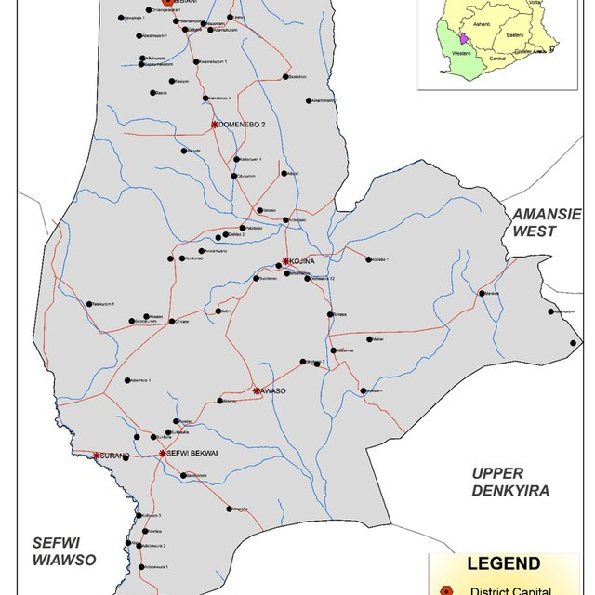

MAP OF BABMA

EXECUTIVE SUMMARY

The Environmental Health and Sanitation Unit of Bibiani Anhwiaso Bekwai Municipal Assembly has numerous sanitation challenges to battle with; paramount among the challenges was political wrangling
To add to the above, despite the continuous Environmental health education for improvement in sanitation practices by the Unit, the attitude of the people towards sanitation and its practices, remain a menace.
These pose a major hindrance to the environmental health and sanitation service delivery in the Municipality. As such, it requires a lot of commitment in terms of staff output, funds, sanitary tools, logistics and equipment support.
However certain improvement and successes were achieved.
Activities carried out were enforcement of environmental protection standard, enforcement of environmental and sanitation laws, control rearing and straying of animals, pest/ vector control, and waste management /disposal of dead (pauper).
Others include environmental monitoring, building sanitation, food/water hygiene and safety, slaughter house duties, and hygiene/health promotion education.
The rest are community mobilization, public relation and complaints, training/skill development, Government priority projects/programmes, revenue mobilization and inter agency collaborative activities.
All these achievements were made with technical staff strength of Nineteen (19) made of (12) males and seven (7) females.
Fifteen (15) Sanitation Guards made of six (6) males and nine (9) females and Thirty-six (36) Sanitary Labourers.
Below are the details;

HUMAN RESOURCE/STAFFING

The Municipality has Nineteen (19) Environmental Health Technical staff, Fifteen (15) Auxiliary staff (Sanitation Guards) and Thirty-Eight (37 Sanitary Labourers.

Below are their details;

Environmental Health Technical staff

NO | NAME | STAFF NUMBER | GRADE | DATE OF APPOINTMENT | DATE OF ASSUMPTION OF DUTY | CONTACT
1 | CEPHAS KWAKU DZAKAH | 61403 | EHA | 1ST JANUARY,1990 | 17TH JUNE 1990 | 0243344989
2 | MATHIAS DIREKAKPIER | 711730 | AEHA | 1ST JULY 2023 | 12TH MARCH,2024 | 0247273379
3 | MAHAMADU SALIFU FUSEINI | 711581 | AEHA | 1ST JULY,2023 | 12TH MARCH,2023 | 0249464133
4 | ASAMOAH KOTO | 140501 | AEHA | 1ST JULY,2023 | 12TH MARCH,2023 | 0243607551
5 | MELODY IVY DOGBE | 632684 | CEHA | 1ST MAY 2011 | 1 JUNE 2011 | 0246531808
6 | MATHEW NYINKON KANDO | 137921 | AEHA | 1ST MAY 2011 | 1 JUNE 2011 | 0248847303
7 | ABUBAKAR RAZAK | 976984 | SEHA | 1ST JUNE 2016 | 1STSEPTEMBER, 2016 | 0249016939
8 | SERWAA MARY | 978270 | SEHA | 1ST JUNE 2016 | 1ST SEPTEMBER 2016 | 0545395902
9 | DANSO STEPHEN | 978216 | SEHA | 1ST JUNE 2016 | 1ST SEPTEMBER 2016 | 0246904234
10 | CLEMENT ANKAMAH | 1353332 | EHO GD II | 22ND JULY 2020 | 13TH OCTOBER, 2020 | 0543291690
11 | GYAMFI YEBOAH PRINCE | 1405501 | EHA | 24TH JULY 2020 | 7TH AUGUST, 2020 | 0554265188
12 | NOAGBE SAMUEL | 1405072 | EHA | 24TH JULY 2020 | 7TH AUGUST, 2020 | 0545590889
13 | HODZIKU GRACE FAFA | 1405062 | EHA | 24TH JULY 2020 | 19TH AUGUST, 2020 | 0247763484
14 | REBECCA OBENG | 1506624 | EHA | 19TH NOVEMBER, 2021 | 13TH JANUARY, 2022 | 0247574443
15 | ADDISON ELLIS NANAYAW BARIMAH |  | AEHA | 29TH,NOVEMBER,2021 | 4TH JANUARY, 2022 | 0248216531
16 | RASHEEDATU ISSAH | 734872 | PEHA | 22ND OCTOBER, 2012 | 14TH DECEMBER, 2012 | 05553532865
17  18  19 | ELIZABETH AYIWA BAFFOE  DANIEL ASANTE  IVY ATAAH MINTAH | 711736  1538691 | PEHA  AEHA  AEHA | 1ST NOVEMBER, 2012  1st JUNE, 2022 | 10TH DECEMBER. 2012  20th JULY, 2022 | 0553689002  0554682983

AUXILIARY STAFF
SANITATION GUARDS

NO | NAME OF GUARD | SEX | ZONAL COUNCIL | GHANA CARD N0 | VOTER’S ID | CONTACT/  MOMO
1 | ISHMEAL YAKUBU | M | BIBIANI | GHA - 720120492-5 | 7037000986 | 0246679514
2 | STEPHEN NKRUMAH | M | ANHWIASO | GHA - 720095850-8 | 6192010160 | 0535623366
3 | DENIS MENSAH | M | ANHWIASO | GHA - 719284814-2 | 5352006521 | 0246327047
4 | AMOAH THOMAS | M | BIBIANI | GHA - 720085559-1 | 6192005608 | 0553623180
5 | ELIZABETH FOLI | F | BIBIANI | GHA - 720153316-6 | 6186004997 | 0541044714
6 | RUTH NKOAH | F | BIBIANI | GHA - 720892454-7 | 8726017661 | 0545862676
7 | MAVIS KUMI | F | BIBIANI | GHA - 720106608-4 | 8071031648 | 0547254840
8 | SEANEHIA ERNESTINA | F | ANHWIASO | GHA - 728429591-9 | 1682003884 | 0244844064
9 | SEIDU SALIFU | M | BEKWAI | GHA -719747146-0 | 1698035008 | 0542524929
10 | AKUA TIWAAH | F | ANHWIASO | GHA -723431758-0 | 1686020368 | 0556155172
11 | PETER GYAMFI | M | BIBIANI | GHA-723948771-8 | 1685020512 | 0241240696
12 | JENNIFER OTUO ACHEAMPONG | F | BIBIANI | GHA - 723664068-0 | 6181019206 | 0544661300
13 | VICTORIA AWUAH | F | BIBIANI | GHA - 721070453-7 | 5292033205 | 0534788038
14 | MATILDA KAKRABA | F | BIBIANI | GHA - 723487626-7 | 1789302716 | 0594596454
15 | KOFI MOGYAGU | M | ANHWIASO | GHA - 720093096-6 | 5847014975 | 0247465270

(SANITARY LABOURERS)

S/N | NAMES OF LABOURER | AREA OF OPERATION
1 | Akot Mankube | Slaughter House
2 | Adoko Ayila | Clearing gangs
3 | Eric Nkrumah | Clearing gangs
4 | Timothy Papunaa | Clearing gangs
5 | Mary Koomson | Clearing gangs
6 | Asibi Galimah | Clearing gangs
7 | Abibata Issah | Clearing gangs
8 | Cecilia Kaagaye | Clearing gangs
9 | Akagyiri Awuni Bisa | Clearing gangs
10 | Asorbe Kangyaga | Clearing gangs
11 | Hawa Amidu | Bibiani New Station
12 | Akosua Asibi | Bibiani New Station
13 | Ishmeal Yakubu | Bibiani New Station
14 | Elizabeth Derry | Bibiani New Station
15 | Asibi Azumah | Bibiani New Station
16 | Lariba Grusi | Bibiani New Station
17 | Kwame Bulsah | Bibiani New Station
18 | E-ka Benye | Bibiani New Station
19 | Mary Amoah | Bibiani New Station
20 | Charles Bangonluri | Mun. Assembly Administration Block
21 | Ama Atola | Mun. Assembly Administration Block
22 | Abena Anabila | Mun. Assembly Administration Block
23 | Peace Avorkliyah | Mun. Assembly Administration Block
24 | Paulina Arhin | Mun. Assembly Administration Block
25 | Kwame Adusah  Osman Gariba  Regina Mensah  Kwadwo Owusu  Yaw Duku  Susana Mintah  Doris Bio  Anastasia Gyapong  Rose Asiedu  John Arthur | Sefwi Bekwai Market
26 |  | Sefwi Bekwai Market
27 |  | Sefwi Bekwai Market
29 |  | Sefwi Bekwai Market
30 |  | Sefwi Bekwai Market
31 |  | Sefwi Bekwai Market
32 |  | Sefwi Bekwai Market
33 |  | Sefwi Bekwai Market
34  35 |  | Sefwi Bekwai Market
36 | Elizabeth Adjei | Mun Env, health office

CHAPTER 1

  - ENVIRONMENTAL PROTECTION STANDARDS ENFORCEMENT

Premises Inspection

Type of  premises | Quantitative  target set | Qualitative  Target Achieved | Common Nuisance  Detected
Domiciliary | 2,050 | 1,520 | Growth of weeds on undeveloped plots, insanitary drains, insanitary premises (yards,) accumulation of refuse on premises, growth of weeds behind premises,  Unauthorized dumping of refuse, dilapidated buildings, accumulation of articles on premises, insanitary bath drains, discharge of waste water on to street. Etc.
Industrial | 30 | 18 | Indiscriminate dumping of waste on premises, growth of weeds on premises, noise nuisance. Ect.
Health Care  Facilities | 24 | 0 | Inspection would be carried out third quarter
Hospitality | 20 | 15 | Spillage of refuse from waste bins,  Exposed safety tanks, operating without certificate of habitation
Educational  Premises | 48 | 1 | Inspection would be carried out third quarter
Markets and  Lorry Terminals | 35 | 25 | Exposed food to flies, selling food without medical certificate,  Selling of vegetables on bare ground etc.
Sanitary sites  and Infrastructure | 25 | 17 | Irregular dislodgement of septic tanks,  Spillage of effluent from septic tanks, Dirty and filthy surroundings, Lack of hand washing facility and Torn roofing sheets, defective Septic tanks. etc

ENFORCEMENT AND PROSECUTION MANAGEMENT

Notices | Abatement  Notices |  |  |  | Injunction Notices |  |  |  | Common Nuisances  Detected
 | Number  Issued |  | Number  Complied  with |  | Number  Issued |  | Number  Complied  with |  | Dumping of refuse at Unauthorized places, Unprotected pits(manhole), Growth of weeds on undeveloped plot of land, human excrement on bare ground,  Accumulation of bath house waste water behind bath house, Insanitary drains and growth of weeds behind premises
 | 158 |  | 98 |  | 0 |  | 0
Key Challenge  (s) | - Lack of motorbikes to monitor sanitation services.  - Inadequate communal refuse containers resulting in dumping elsewhere.  - Political Iterfearance
Criminal  Summons | Number  Issued | Number  Served |  | Number  Prosecuted |  | Number  of Bench  Warrant  Issued |  | Result of Cases |  |  | Cases Adjourned
 |  |  |  |  |  |  |  | Cases won |  | Cases Lost | Cases Adjourned
Criminal  Summons | 8 | 8 |  | 0 |  | 0 |  | 0 |  | 0 | 0
Key Challenge  (s) | - Reposting of the sitting Magistrate delayed court processes

STRAY ANIMALS CONTROL

Type of Animals | Cattle | Sheep | Goat | Pigs | Others
Number of animals arrested | 0 | 18 | 31 | 1 | 0
Number of Owners fined | 0 | 18 | 31 | 1 | 0
Number of Owners  Prosecuted | 0 | 0 | 0 | 0 | 0
Key Challenge (s) | - No animal pen.  - Lack of funds for renting of vehicle

PEST AND VECTOR CONTROL AND OTHER ENTOMOLOGICAL
ACTIVITIES

Type  of Pest | Control Measures – (Larviciding/ adulticiding/ Derating/  Imagociding e.t.c)
Mosquitoes/ other vectors | Biological | Chemical | Environmental | Mechanical | physical
 |  | 0 | 0 | 0 | 0
Key Stakeholders
• Zoomlion Gh. Limited
• Ghana Health Service
Media Houses

WASTE MANAGEMENT

Solid Waste  Management | - Sweeping, collection, storage and disposal.  - Management of refuse dumpsites
Liquid Waste
Management

POPULATION WITH HOUSEHOLD TOILET

Household Latrine Facilities performance from October – December 2022

No | ZONAL COUNCIL | FACILITY TYPE | No | No OF HOUSEHOLD | SHARE | USER POP.
1 | BIBIANI | WC | 591 | 611 | 20 | 3,055
1 | BIBIANI | VIP | 204 | 229 | 25 | 1,145
1 | BIBIANI | POUR FLUSH | 94 | 104 | 10 | 520
1 | BIBIANI | BIOFILL | 146 | 154 | 8 | 770
1 | BIBIANI | TOTAL | 1,035 | 1,098 | 63 | 5,490
2 | HUMJIBRE | WC | 62 | 82 | 20 | 492
2 | HUMJIBRE | VIP | 157 | 182 | 25 | 1,092
2 | HUMJIBRE | POUR FLUSH | 44 | 54 | 10 | 324
2 | HUMJIBRE | BIOFILL | 24 | 32 | 8 | 192
2 | HUMJIBRE | TOTAL | 287 | 350 | 63 | 2,100
3 | LINESO | WC | 73 | 93 | 20 | 558
3 | LINESO | VIP | 133 | 158 | 25 | 948
3 | LINESO | POUR FLUSH | 68 | 78 | 10 | 468
3 | LINESO | BIOFILL | 29 | 37 | 8 | 222
 |  | TOTAL | 303 | 366 | 63 | 2,196
4 | ASAWINSO | WC | 79 | 99 | 20 | 594
4 | ASAWINSO | VIP | 139 | 164 | 25 | 984
4 | ASAWINSO | POUR FLUSH | 72 | 82 | 10 | 492
4 | ASAWINSO | BIOFILL | 24 | 32 | 8 | 192
 |  | TOTAL | 314 | 377 | 63 | 2,262
5 | WENCHI | WC | 89 | 109 | 20 | 654
5 | WENCHI | VIP | 134 | 159 | 25 | 954
5 | WENCHI | POUR FLUSH | 75 | 85 | 10 | 510
5 | WENCHI | BIOFILL | 14 | 22 | 8 | 132
 |  | TOTAL | 312 | 375 | 63 | 2,250
6 | SUBRI | WC | 76 | 96 | 20 | 576
6 | SUBRI | VIP | 232 | 257 | 25 | 1,542
6 | SUBRI | POUR FLUSH | 72 | 82 | 10 | 492
6 | SUBRI | BIOFILL | 21 | 29 | 8 | 174
 |  | TOTAL | 401 | 464 | 63 | 2,784
7 | ANHWIASO | WC | 91 | 111 | 20 | 391
7 | ANHWIASO | VIP | 213 | 238 | 25 | 916
7 | ANHWIASO | POUR FLUSH | 73 | 83 | 10 | 314
7 | ANHWIASO | BIOFILL | 39 | 47 | 8 | 168
 |  | TOTAL | 416 | 479 | 63 | 2,874
8 | BEKWAI | WC | 367 | 387 | 20 | 1,935
8 | BEKWAI | VIP | 217 | 242 | 25 | 1,210
8 | BEKWAI | POUR FLUSH | 114 | 124 | 10 | 620
8 | BEKWAI | BIOFILL | 91 | 99 | 8 | 495
 |  | TOTAL | 789 | 852 | 63 | 4,260
9 | AWASO | WC | 84 | 104 | 20 | 624
9 | AWASO | VIP | 152 | 177 | 25 | 1,062
9 | AWASO | POUR FLUSH | 61 | 71 | 10 | 426
9 | AWASO | BIOFILL | 37 | 45 | 8 | 270
 |  | TOTAL | 334 | 397 | 63 | 2,382
 |  | GRAND TOTAL | 4,191 | 4,758 | 567 | 24,336

Total number of latrine constructed during the period = 270
Total coverage during the period = 6.4%

Household Latrine Facilities performance from January – March 2023

No | ZONAL COUNCIL | FACILITY TYPE | No | No OF HOUSEHOLD | SHARE | USER POP.
1 | BIBIANI | WC | 617 | 637 | 20 | 3,185
1 | BIBIANI | VIP | 206 | 231 | 25 | 1,145
1 | BIBIANI | POUR FLUSH | 94 | 104 | 10 | 520
1 | BIBIANI | BIOFILL | 157 | 165 | 8 | 825
1 | BIBIANI | TOTAL | 1,074 | 1,137 | 63 | 5,675
2 | HUMJIBRE | WC | 71 | 91 | 20 | 546
2 | HUMJIBRE | VIP | 161 | 186 | 25 | 1,116
2 | HUMJIBRE | POUR FLUSH | 47 | 57 | 10 | 342
2 | HUMJIBRE | BIOFILL | 29 | 37 | 8 | 222
2 | HUMJIBRE | TOTAL | 308 | 371 | 63 | 2,226
3 | LINESO | WC | 82 | 102 | 20 | 612
3 | LINESO | VIP | 136 | 161 | 25 | 966
3 | LINESO | POUR FLUSH | 71 | 81 | 10 | 486
3 | LINESO | BIOFILL | 32 | 40 | 8 | 240
 |  | TOTAL | 321 | 384 | 63 | 2,304
4 | ASAWINSO | WC | 82 | 102 | 20 | 612
4 | ASAWINSO | VIP | 144 | 169 | 25 | 1,014
4 | ASAWINSO | POUR FLUSH | 77 | 87 | 10 | 522
4 | ASAWINSO | BIOFILL | 31 | 39 | 8 | 234
 |  | TOTAL | 334 | 397 | 63 | 2,385
5 | WENCHI | WC | 93 | 113 | 20 | 678
5 | WENCHI | VIP | 141 | 166 | 25 | 996
5 | WENCHI | POUR FLUSH | 77 | 87 | 10 | 522
5 | WENCHI | BIOFILL | 21 | 29 | 8 | 174
 |  | TOTAL | 332 | 395 | 63 | 2,370
6 | SUBRI | WC | 81 | 101 | 20 | 606
6 | SUBRI | VIP | 241 | 266 | 25 | 1,596
6 | SUBRI | POUR FLUSH | 75 | 85 | 10 | 510
6 | SUBRI | BIOFILL | 24 | 32 | 8 | 192
 |  | TOTAL | 421 | 484 | 63 | 2,904
7 | ANHWIASO | WC | 97 | 117 | 20 | 702
7 | ANHWIASO | VIP | 217 | 242 | 25 | 1,452
7 | ANHWIASO | POUR FLUSH | 73 | 83 | 10 | 498
7 | ANHWIASO | BIOFILL | 43 | 51 | 8 | 306
 |  | TOTAL | 430 | 493 | 63 | 2,958
8 | BEKWAI | WC | 391 | 411 | 20 | 2,466
8 | BEKWAI | VIP | 224 | 249 | 25 | 1,494
8 | BEKWAI | POUR FLUSH | 122 | 132 | 10 | 792
8 | BEKWAI | BIOFILL | 108 | 116 | 8 | 696
 |  | TOTAL | 845 | 908 | 63 | 5,448
9 | AWASO | WC | 96 | 116 | 20 | 696
9 | AWASO | VIP | 161 | 186 | 25 | 1,116
9 | AWASO | POUR FLUSH | 64 | 74 | 10 | 444
9 | AWASO | BIOFILL | 49 | 57 | 8 | 342
 |  | TOTAL | 370 | 433 | 63 | 2,598
 |  | GRAND TOTAL | 4,435 | 5,002 | 567 | 28,868

Total number of latrine constructed during the period = 244
Total coverage during the period = 5.5%

DISPOSAL OF THE DEAD

Name and  Location of  Cemetery | Status of the Dead |  |  |  |  |  | Exhumation by Court Order |  | Death from  Communicable  Disease
Name and  Location of  Cemetery | Normal |  |  |  | Pauper |  |  |  | Death from  Communicable  Disease
Bibiani Public Cemetery | Male Adult | Female Adult | Male Child | Female Child | Male | Female | Male | Female
 | 12 | 19 | 0 | 0 | 0 | 0 | 0 | 0 | 0
Key Challenge (s) | - With the exception of Bibiani township cemetery, the rest of the cemetery are being managed by traditional authorities in the communities

ENVIRONMENTAL MONITORING

Galamsey and sand winning sites at Akaaso, Mmerewa and Manse Lineso and Basengele

Findings
• Contamination/pollution of streams and rivers in these areas are on the increase.
• Unfilled excavated pits serving as death trap to human and animals were not filled.
• Unfilled pits serving as potential sources of breeding grounds for mosquitoes.

Recommendation
It is therefore recommended that;

- • Management form a committee led by Environmental Health and Sanitation Unit to
- Compel the illegal miners (galamseyers) to fill all pits dug.
- Compel sand winning contractors to reclaim the site.
- Task Larvae source management team to render water in the pits un favourable for breeding of mosquitoes as a short term measure.

MONITORING OF ENVIRONMENTAL SANITATION SERVICES

Name of Environmental Sanitation Service provider(s) | Category of Service  provider | Expected output of  Service provider | Remarks
Zoom-Lion GH. | SPI (Sweeping, Collection,  Storage and  Disposal of  solid waste) | To ensure clean  environment | Carried out  successfully
Waste Land Fills Company Limited | Management of Final Solid waste Disposal Sites | Maintain Final Solid Waste Disposal sites | Pushing and eveling was done

BUILDING SANITATION

Number of permit  Development application received  by the Municipal Assembly | Number approved by the Assembly | Number issued with  certificate of habitation by the  Assembly | Number of permit  application rejected
0 | 0 | 0 | 0

CHAPTER TWO

FOOD AND WATER HYGIENE MARKET SANITATION

Name of Market | Number of inspection  carried out in the market during the period | Key findings  from the inspection | Remarks
Bibiani Main Weekly Market (Friday) | 1 | - Inadequate sanitary facilities in the market  - Vegetables displayed on bare ground  - Inadequate waste bins in the markets.  - No hand washing facilities.  - Sales of Unprotected food  - Roof leakage at Bibiani old market | - Bibiani old market needs total renovation.  - Food vendors were educated to keep their food items safe from contamination.  - Sanitary facility be provided at Bibiani old market
Bibiani Weekly Mini Market (Monday) | 1
Bibiani Daily Market | 3
Bekwai Main Weekly Market (Wednesday) | 4
Anhwiaso Weekly Market(Thursday) | 3
Awaso Daily Market | 2
Asawinso Daily Market | 3
Nkatieso Daily Market | 2

MEDICAL/HEALTH SCREENING OF FOOD HANDLERS

Number Registered | Number Screened | Sex |  | Result |  | Specific Condition(s)
Number Registered | Number Screened | Male | Female | Pos(+) | Neg(-) | Specific Condition(s)
25 | 25 | 8 | 17 | 0 | 25 | 0
Key Challenge(s) | - In adequate logistics

SANITATION OF FOOD ESTABLISHMENTS

Name of food establishment by location | Number of inspection  carried out during the  period | Key findings from the inspection | Remarks
Diamond Pub and catering services, Bibiani | 2 | Refuse exposed to flies and domestic  animals | Abatement notice was served and nuisance abated
Cilla Catering services Bibiani | 1 | Workers not having health certificate. | The owner was advised to come and screen the workers
Evelyn Arthur- Asawinso Kitua | 1 | Preparing food in an open space likely to contaminate food. | Owner was asked to get a kitchen for the preparation of food
Mel come Ghana – Bibiani | 1 | Rats infestation, accumulation of article on premises | Manager was advised to eliminate rats and to remove the accumulated articles from the premises
Saraban provision store – Bibiani | 1 | Expired food products: eg. Tin milk, corn flakes, blue ban etc.  Dented products: Tin fish, Ideal milk, | Expired food products were seized and disposed off
Abizie provision store- Bibiani | 1 | Expired food product: Dano cool cow, nestle nido, nescafé  Dented products:  Heinz beans, beef pat, dano milk | Expired food products were seized and disposed off

MEAT AND FISH HYGIENE

Name and location  of slaughter facilities (Slaughterhouse/  Slab) | Type of Slaughter  Facilities | Nature of Meat Shops |  | Singeing material used
 | Type of Slaughter  Facilities | Clean | Dirty | Gas | Firewood | Old Lorry tyre
Bibiani Newtown | Slaughter Slab | ✓  √ |  | ✓  √
Bekwai Lighthouse | Slaughter Slab | ✓ | √ |  |  | ✓  √
Awaso Old market | Slaughter slab |  | √ |  |  | √

NB Bekwai has a new slaughterhouse facility yet to be commissioned

SLAUGHTER HOUSE DUTIES/MEAT INSPECTION

Type of Animals Slaughtered | Number of Carcasses Inspected | Number of rejected carcasses(part) | Disease/Condition
Sheep | 245 |  | 0
Goat | 286 | 0 | 0
Cattle | 290 | 0 | 0
Pig | 0 | 0 | 0
Key Challenges | - Lack of approved meat van to convey meat to the meat shop  - Lack of water storage facility at Bibiani and Bekwai.  - Lack of toilet facility

CHAPTER THREE

ENVIRONMENTAL HEALTH PROMOTION AND EDUCATION

School Health Activities
Name, Location and contact of head of School | Category of School |  | Service provided  during the period under review  (population by sex) |  |  | Health inspection
Name, Location and contact of head of School | Private | Public | Total | Male | Female | Health inspection
Engineer Kwaakye –Bekwai | √ |  | 42 | 30 | 12 | General sanitation, Personal hygiene, Hand washing, waste management etc.

COMMUNITY MOBILIZATION

Name and location  of community | Date of community  mobilization | Purpose of community  mobilization | Sex dis-aggregation of  participant
Name and location  of community | Date of community  mobilization | Purpose of community  mobilization | Male | Female
Bekwai | 28 – 04- 2024 | Clean up exercise | 128 | 153
Bekwai | 12 -05 – 2024 | Clean up exercise | 154 | 188
Nambro | 20-05-2024 | Household toilet construction | 7 | 11
Subri Nwkanta | 25-05-2024 | Clearing and weeding of community dump site | 18 | 22
Emfranyo | 04-06-2024 | Clearing and weeding of community dump site | 9 | 13
Kumkumso | 29-06-2024 | Proper waste management, especially indiscriminate dumping | 8 | 23
Tanoso | 08-06-2024 | Construction of household toilet | 18 | 1

PUBLIC RELATION AND COMPLIANTS

Source of  complaint (name  of complainant,  community) |  | Type of  complaint | Action taken  on complaint | Remarks
Kofi Alabaya  (Old town) |  | Discharge of human effluent into stream | Care taker was invited to office and educated on the negative health effects and was asked to stop that act. | Order complied with
Salifu Yakubu  (Compound) |  | Burning of refuse on premises by Madam Lucy, which is creating smoke nuisance | One week notice of abatement served | Complied
Benard Ofori  ( Gyeakuase) |  | An alleged siting of latrine close to hand dug well | Owner was invited to office and was given education and keen monitoring carried out to ensure necessary measures put in place to prevent contamination of the well water | Owner complied with directives given by the environmental officers.
Elizaberth Gyan  ( Whenampoli) |  | Channeling of Waste water onto neighbor’s building plot | Culprit was asked to construct soak away pit to contain the water | Culprit complied with the directives given by the Env’tal health officers
Adu Sarah  (Kalifonia) |  | Poultry farm producing offensive odour to neighbourhood. | Site was visited and culprit was asked to relocate birds to existing vacant structure and use the contention structure for feed store. | Culprit complied with directives
Addae Mensah Alex  (Adupuri) |  | Farm(plantation) being damaged by cattle which belong to Paul Gyedu and Beuiasee. Several warnings were given but to no avail. | Farm site was visited and culprit was asked to take good care of the animals to prevent further destruction of people’s farms | Culprit complied with directives and under taken was signed not to repeat that practice.
Gifty Danso  (Hwenampoli ) |  | Smoke nuisance produced by charcoal burner | Culprit reported to office and the agreement was that, evacuation of the loaded charcoal and pack off on vacated site by 17 June, 2024 | Site was revisited on the 20th of June, 2024, and culprit complied.
Shadrack Anyasor  (Linso) |  | Discharge of waste water from bath house by Mercy Obour on to my premises which is producing offensive odour. | Env,tal Health Officers visited site and came to agreement that, soak away pit should be constructed by the end of June,2024 | Culprit complied.
Mary Nkuah  ( Aanwinso Kitua) |  | Construction of a household latrine on street | Site was inspected and culprit was asked to continue with the construction | Issue resolved amicably
Gifty Asante  ( Hwenampoli Abesi Nsuo road) | Defective pit latrine on your premises inducing offensive odour and serving as jubilation ground for house flies an d insect, e.g cockroaches |  | Short term measure  - Cover pit holes with a fitting cover.  - Rpair roof  - Introduce P V C Pipe for ventilation  - Stop the application  of ask and dirty oil into the pit to reduce volume of fecal matter  Long term measure  - Relocate new facility |  | Issue still in progress or not fully resolved.
Nana Yaw Antwi  Nana Owusu Gyekyi Kwagyan  ( Amokrom) | Five (5) Stray animals were impounded by Chief of Amokrom and brought to office |  | Animals were auctioned to the public |  | Issue resolved.
Collins Nipah  (Kwamekrom | Stray pigs destroying cassava farm product. |  | Site visited |  | Issue still pending.

RESEACH AND MANAGEMENT INFORMATION SYSTEM

Data and management information system | Status | Key Challenges
_ | _

TRAINING AND SKILLS DEVELOPMENT

Name of Staff | Grade | Tittle of Training | Facilitating Organization/Institution
Nil | Nil | Nil | Nil

CHAPTER FOUR

SUSTAINABLE DEVELOPMENT GOAL (SDGs) COMPLIANCES

ACTIVITIES

SDG indicator | Target | Activities being  implemented | Status Update
Water and Sanitation  (Goal 6) | Landlords | Education given to household heads to own household latrine facilities | Education ongoing.

STATUS OF GOVERNMENT PRIORITY PROJECT OR
PROGRAMMES

Government  Priority Project | Target | Activities being  Implemented | Status Update
Ghana First projects | People in transit | Construction of public Toilets | Projects Abandoned
Construction of slaughterhouse at Bibiani | Butchers | Construction of New Slaughter House at Bibiani | ongoing
Commissioning of Slaughterhouse at S/Bekwai | Butchers | Commissioning of New Slaughter House at Bekwai

REVENUE MOBILIZATION

Source of revenue | Planned target for the Period | Planned target for the reporting period | Target achieved during the reporting  period
Cemetery  Management | GhȻ 6000.00 | GhȻ 3000.00 | GhȻ 2,540
Medical screening of food Handlers | GhȻ 10,000.00 | GhȻ 6000-.00 | GhȻ -250.00
Stray animal arrest | GhȻ 2,000.00 | GhȻ 500.00 | Ghc 800.00
Slaughtering fee | GhȻ 10,000.00 | GhȻ 5000 | GhȻ 4,444.00

INTER-AGENCY COLLABORATIVE ACTIVITIES

Type of activity | Collaborators/Partners | Role of Environmental  Health Officers | Remarks
Site Inspection and Vetting of building Applications | Works Department, NADMO, EPA, Physical Planning Unit, Fire Service, Development Planning, ECG | Vetting of building Plans (ensure adequate sanitary facilities in building plans and assess suitability of lands for buildings) | Successful
Clean up Exercise | Fire Service, Police, Religious Groups and Traditional Leaders (Nananom) | Organization and implementation | Successful

LOGISTICS STOCK

Type of logistic | Number/Quantity | Functionality status
Type of logistic | Number/Quantity | Functioning | Not  functioning
Chairs | 14 | 14✓ | 0
Desktop Computer  and accessories | 0 | 0 | 0
Table | 3 | 3 | 0
Mist Blower | 3 | 2 | 1
Insecticide | 0 | 0 | 0
Printer | 1 | 0 | 0
Digital camera | 0 | 0 | 0
Projector | 0 | 0 | 0
Projector Screen | 0 | 0 | 0
Slashes | 0 | 0 | 0
Cutlass | 0 | 0 | 0
Wellinton boot | 0 | 0 | 0
Hand Gloves (Surgical) | 0 | 0 | 0
Wheelbarrow | 0 | 0 | 0
knapsack sprayer | 0 | 0 | 0

OVERALL ACHIEVEMENT

Withstanding the numerous challenges faced by the Bibiani Anwhiaso Bekwai Municipal Assembly (BABMA) of which the Unit was no exception, the following successes were achieved;
- Daily public cleansing, emptying of communal refuse containers and sanitary disposal of refuse was carried out during the period.
- Promotion of household latrine construction through radio education.
- Collaborated with Nananom, Religious groups, Government agencies and private entities to organized two (2) clean up exercises at Bibiani Bekwai
- Carried out School health education in thirteen (1) private basic school in Bibiani Bekwai

OTHERS

The Unit has also received six (6) National Service Personnel (Registered Public Health and Community Health Nurses) from the Bibiani Municipal Health Directorate, to continue with their national Service for one (1) week each within the quarter.

Below are the names of the personnel

S/N | NAME | PROGRAMME | DURATION
1 | MS. MABEL BASERKWOGO | REGISTERED PUBLIC HEALTH NURSE | 27TH MAY TO 2ND JUNE, 2024
2 | MS. MONICA ANANE | REGISTERED PUBLIC HEALTH NURSE | 29TH MAY TO JUNE, 2024
3 | MS. LYDIA BOAKYE | REGISTERED COMMUNITY HEALTH NURSE | 3RD JUNE TO 9TH JUNE, 2024
4 | MS. LINDA MENSAH | REGISTERED COMMUNITY HEALTH NURSE | 5TH JUNE TO 11TH JUNE, 2024
5 | MS. ESTHER NKUAH | REGISTERED COMMUNITY HEALTH NURSE | 5TH JUNE TO 11TH JUNE, 2024
6 | MS. BEATRICE ADU PAKO | REGISTERED COMMUNITY HEALTH NURSE | 13TH JUNE TO 19TH JUNE,2024

WORK PLAN FOR SECOND (2ND) QUARTER - 2024

S/N | ACTIVITY | LOCATION | TIME FRAME 2024 | INDICATORS | IMPLEMENTING AGENCIES
 |  |  |  |  | LEAD | COLLABORATIVE
01 | Food Hygiene /Safety | Municipal wide | April-June | Conducted health / medical screening mob up for 600 food handlers | EHSU | Ghana Health Service & Media Houses
02 | Control, rearing and straying of animals | Municipal wide | April - June | Animal rearers educated in 10 communities.  Straying animals were seized and impounded quarterly. | EHSU | Ghana Police Service &  Media Houses
03 | Promotion of household latrine construction through radio engagement | Municipal wide | April - June | - E H O trained ii) Held meetings with opinion leaders, data collected and triggering carried out in 5 communities  iii)Household latrines under construction monitored | EHSU | Media Houses
04 | Daily Public cleansing | Municipal wide | April - June | Daily Public cleansing carried out | EHSU | Central Administration, Media Houses &  Religious groups
05 | Premises Inspection | Municipal wide | April - June | 2,050 Premises Inspected | EHSU | Central Administration
06 | Disinfection and  Disinfestation | Municipal wide | April - June | Public places and premises disinfected/disinfested | EHSU | Central Administration
07 | School Health | Municipal wide | April - June | Promote public health /hygiene education in 3 basic schools | EHSU | Central Administration, Education Service
08 | Public Health / Hygiene Education | Municipal wide | April - June | Carried out public health /hygiene education in 5 communities | EHSU | Central Administration,
9 | Quarterly Performance Review Meeting with Environmental Health Zonal Heads | Municipal Head Quarters | April - June | 2nd quarter Meetings Carried out | MEHA | Central Administration
10 | Quarterly Meeting with Sanitation Services Providers | Bibiani | April - June | 2nd quarter Meeting held | EHSU | Central Administration,
11 | Quarterly Clean Up Exercise | Bibiani & Bekwai | April - June | 2nd quarter Clean Up Exercise organized at Bekwai | EHSU | Central Administration, Keep Fit Clubs & Religious bodies
12 | Renovation of Meat Shops | Bekwai, Bibiani & Awaso | April - June | Renovation works carried out | EHSU | Central Administration
13 | Monitoring of Sanitation Services | Municipal wide | April - June | Daily service monitored | EHSU | Central Administration

KEY CHALLENGES IN ENVIRONMENTAL HEALTH AND
SANITATION MANAGEMENT IN THE MUNICIPALITY

- Lack of motorbikes for monitoring sanitation and environmental health activities.
- Irregular lifting of communal containers by Zoom Lion
- Inadequate resources to carry out behavioral change programmes
- Inadequate funds to carry out medical/ health screening of food handlers

RECOMMENDATIONS

The Unit recommends as follows;
- Those Assembly Purchases motorbikes to Environmental health and sanitation unit for monitoring of sanitation and hygiene activities.
- Zoom Lion be advised to lift communal refuse containers regularly
- That Assembly provides the Unit with resources to carry out more behavioral change
Programmes
d. That the assembly provides funds and logistics to carry out medical/health screening in the municipality.

CONCLUSION
If all the above recommendations are adhered to, the health and economic status of the people in the Municipality will improve.

Pictorial evidence of some of the activities carried out within the quarter.

E. H. O S CARRIED OUT INSPECTION AT SILLAS KITCHENS IN BIBIANI

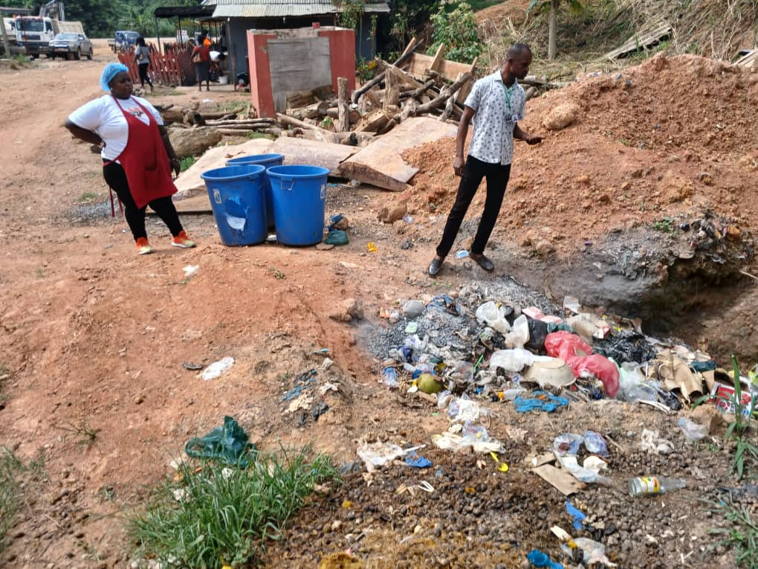

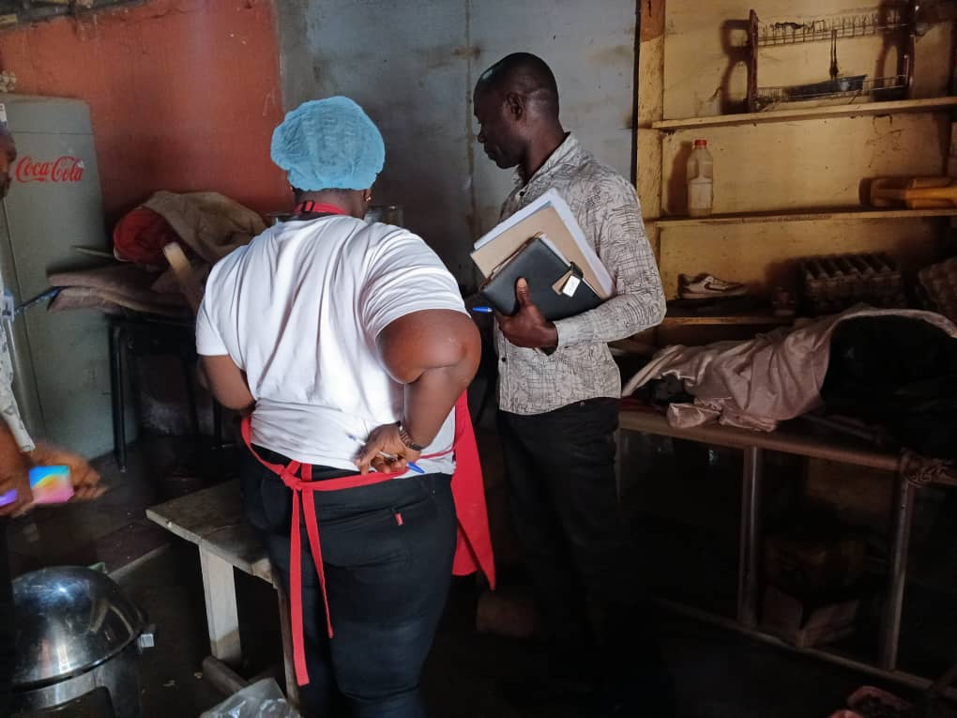

E H O S AND SERVICE PERSONNELS CARRYING OUT INSPECTION OF EXPIRED FOOD PRODUCTS IN BIBIA

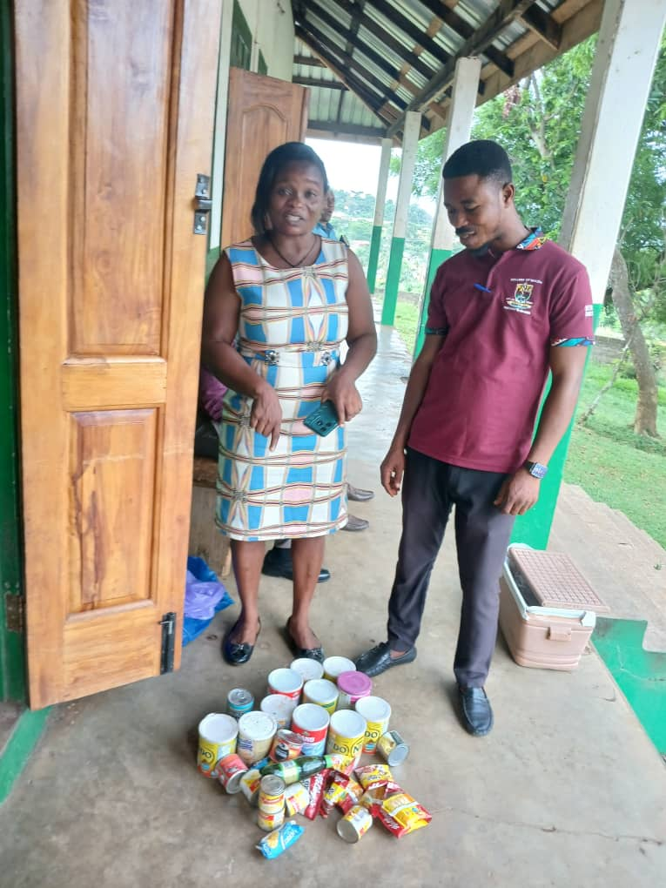

E H O S CARRIED OUT INSPECTION AT SCRUB DEALER’S SHOP IN BIBIAINI

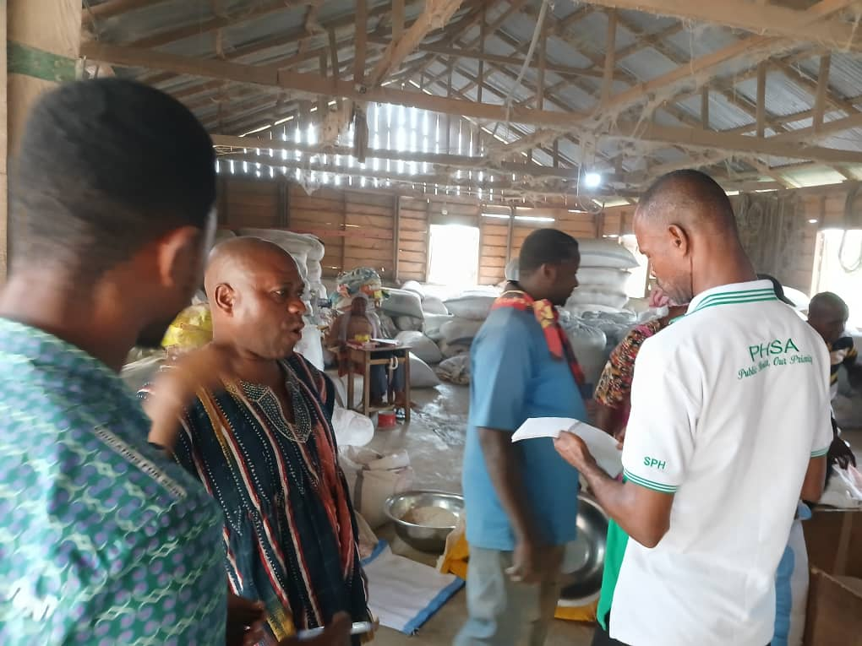

E. H. O. S INSPECTED A COMMUNITY DUMPING SITE AT BIBIANI ZONGO

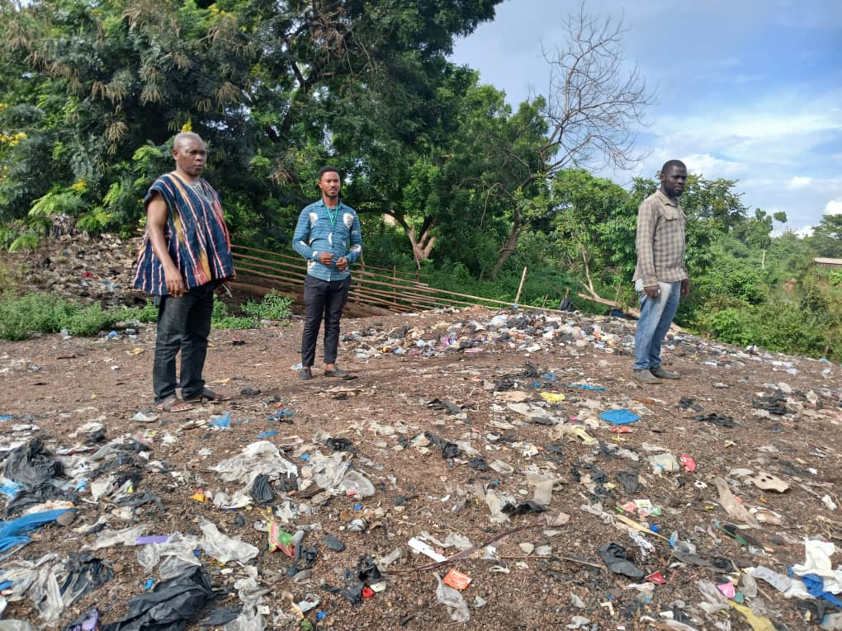

E.H. O. S CARRIED OUT INSPECTION OF PUBLIC TOILET AT BIBIANI ZONGO

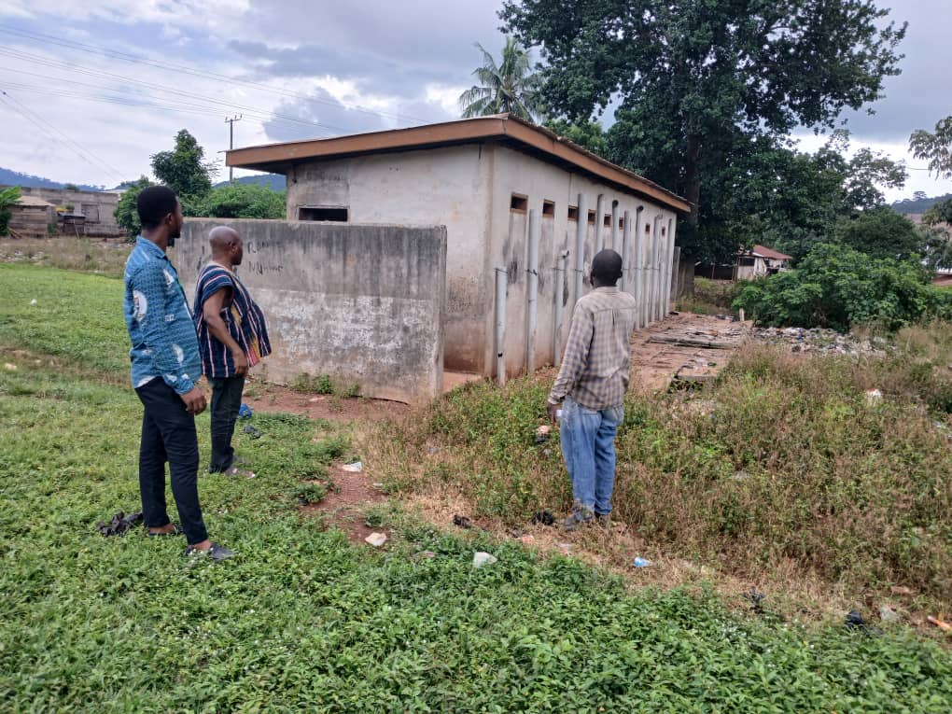

E H O S UNDERTAKING INSPECTION AT CORN AND RICE MILL IN BIBIANI

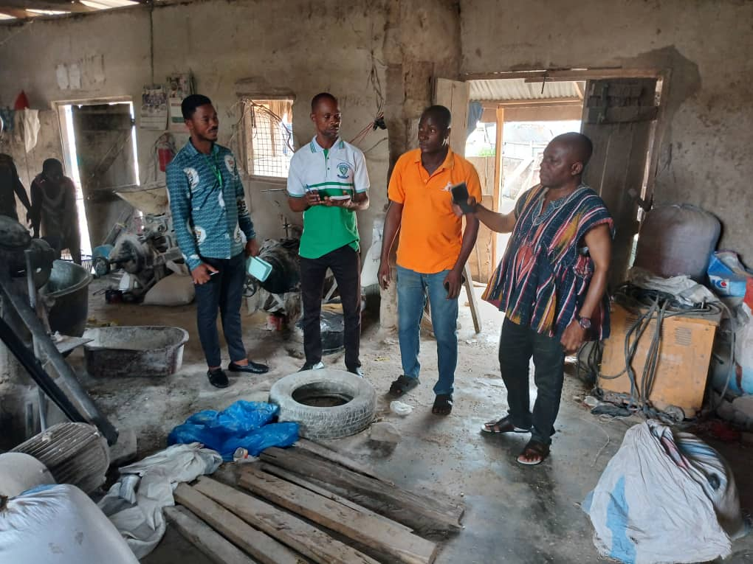

OFFICERS CARRYING OUT INSPECTION AT CRYSTAL WATER PRODUCING COMPANY

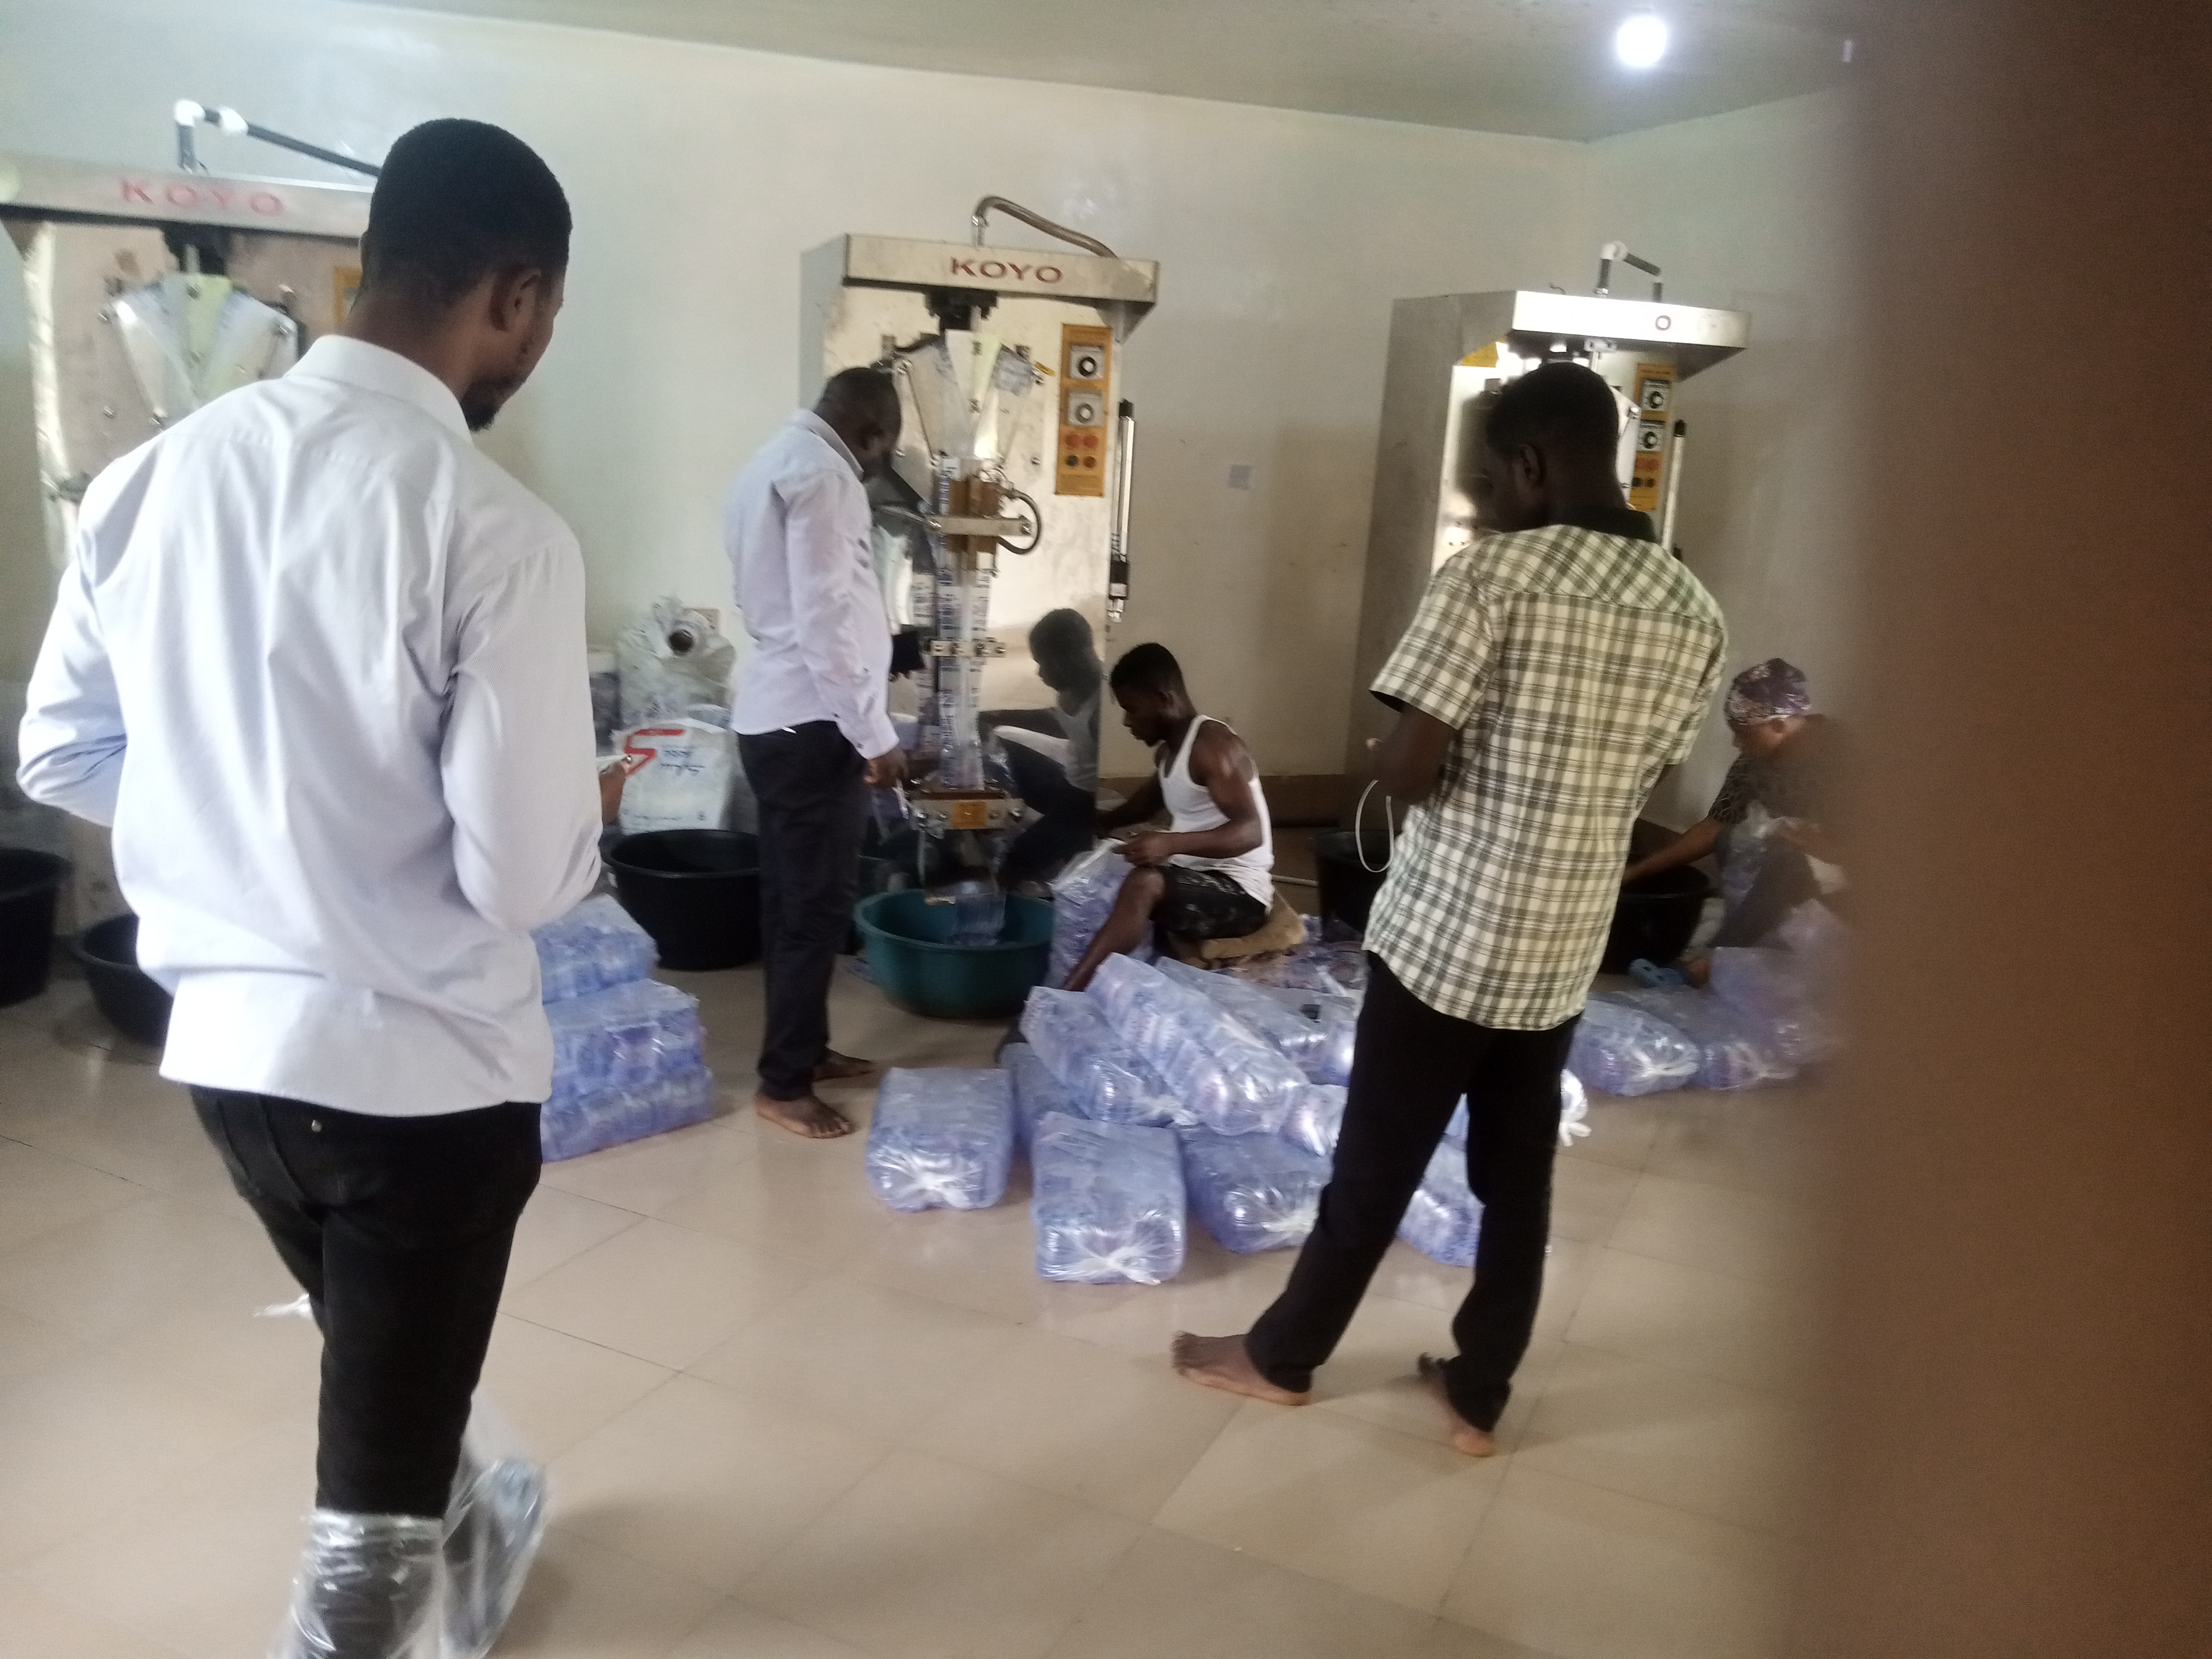

PUSHING AND LEVELING OF FINAL BIBIANI DISPOSAL SITE


