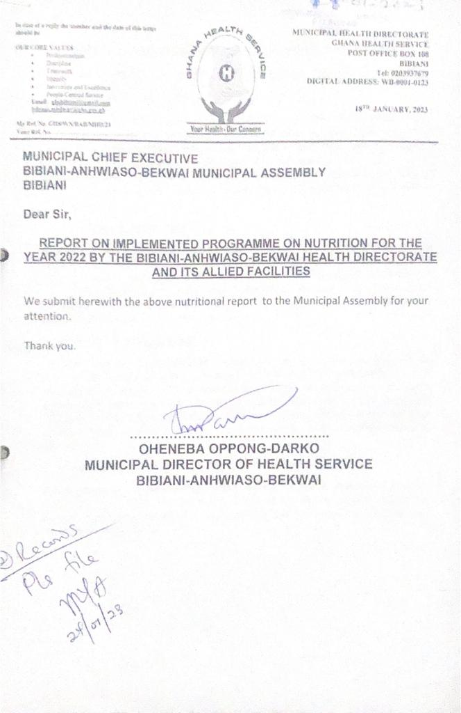BIBIANI-ANHWIASOIBEKWAI MUNICIPAL HEALTH DIRECTORATE
NUTRITION PRGRAMS UNDER IMPLEMENTATION IN THE MUNICIPALITY FOR 2022
- UNDER FIVE CHILD WELFARE CLINICS
This is a service that is being rendered at the various health facilities and community level by health workers to monitor the growth and health status of babies from Day 1 to five years of the child year. Monthly sensitization programmes were held on both radio band communities to reduce infant and adult malnutrition in the municipality. This service helps to track the feeding status and nutritional status, health education for nursing mothers, vaccination of the child when due for immunization against a particular disease, vitamin A supplementation and as well as child registration.
- MATERNAL NUTRITION
Maternal nutrition refers to the nutritional needs of women prior to conception and during antenatal and postnatal care period and this considers nutrition before pregnancy, during pregnancy, whiles breastfeeding and all of these when practiced well help reduce both maternal and infant morbidity and mortality. These interventions are meant to promote healthy pregnancies, reduce risk of birth complications, infants’ health prevention from micronutrients and improve maternal health in the municipality.
- START RIGHT FEED RIGHT
This is an infant and young child feeding campaign that starts from birth up to two year of the child age and this campaign aims at increasing early initiation of breastfeeding within one hour after delivery, increase exclusive breastfeeding at six months and increase the percentage of children fed the minimum acceptable diet. By addressing nutrition during the critical early years of life, the "Start Right, Feed Right" program can have far-reaching positive effects on individual children, families, communities, and the nation, contributing to a healthier and more prosperous future for Ghana.
- GIFTS (GIRLS IRON-FOLATE SUPPLEMENTATION)
This programme is a public health intervention designed to provide adolescent girls with a weekly iron and folic acid tablets free of charge to help prevent anaemia because this intervention aims to provide once weekly iron and folic acid supplement in both in school and out of school adolescent girls.

- NFSI (NUTRITION FRIENDLY SCHOOLS INITIATION)
NFSI is an initiative implementation which incorporates interventions such as the intake of fruits and vegetables days by the school children, health inspection days, general cleaning of school compounds, physical activities day, Girls’ Iron and Folic Acid table supplement, nutrition education.
- DIETARY RELATED DISEASE CLINICS
This is a service that focuses on giving health education and support on emerging non-communicable diseases such as hypertension, stroke, diabetes. Incorporating dietary-related disease clinics into the healthcare system in the municipality can lead to positive health outcomes, improved patient engagement, and a stronger focus on preventative care, ultimately contributing to healthier communities and reduced burden on healthcare resources.
STRATEGIES USED AND TO BE USED
- Radio program every Saturday morning on local FM station in Bibiani and Sefwi Bekwai on nutrition and public health related issues targeted at improving the quality of nutritional status of the populace.
- Nutrition education for aggregate groups during routine service such as CWC, ANC and PNC etc.
- In partnership with Care Ghana, NCCE, Municipal Environmental and Sanitation Unit, Municipal Education Directorate and local FM station will carry out sensitization activities in communities and public areas on nutrition through food demonstrations.
- Collaboration with Municipal Assembly to coordinate GIFTS activities in school.
- Involve community members from the outset to gain their insights and build trust. Community leaders, local influencers, and traditional authorities can play a pivotal role in advocating for and supporting the program.
- Adapt program materials and messages to align with local cultural norms and values. Respectful integration of traditional practices and beliefs can enhance acceptance and engagement.
- Organize workshops, seminars, and community meetings to provide hands-on nutrition education, cooking demonstrations, and interactive sessions that encourage active participation.

SN | ACTIVITY | TARGET GROUP | EXPECTED BENEFICIARIES
1. | UNDER FIVE (5) CHILD WELFARE CLINICS AND CHPS | All children under 5 years with in the Municipal | 40,307
2 | MATERNAL NUTRITION | All Reproductive women especially pregnant and Nursing mothers | 33,589
3 | START RIGHT FEED RIGHT | Babies from Birth to 2years | 13,436
4 | GIFTS (GIRLS IRON – FOLATE SUPPLEMMENTATION) | Adolescent age 10-19 years | 8,000
5 | NFSI (NUTRITION FRIENDLY SCHOOLS INITIATION | Some selected schools and children | 1,351
6. | DIETARY RELATED DISEASE CLINICS AND CHPS | All aged and vulnerable persons especially all diabetics and hypertensive patients etc. | 7,000
7 | PROMOTION OF NUTRITIONALLY SENSITIVE AND COST-EFFECTIVE DIET | All nutritionally dense food items especially the locally produced foods and vegetables | 6,000
8 | PROMOTE THE PRODUCTION OF DIVERSIFIED, NUTRIENT-RICH FOOD AND CONSUMPTION OF NUTRITION FOODS | All ages especially women, children, and youth | 2,000
9 | CONDUCT DEMONSTRATIVE ENGAGEMENT ON KITCHEN GARDENS AND BALANCE DIETS IN COMMUNITIES | Identified communities identified as high-risk areas for malnutrition in the municipality | 3,500
Source: BABMA- MHD -2022

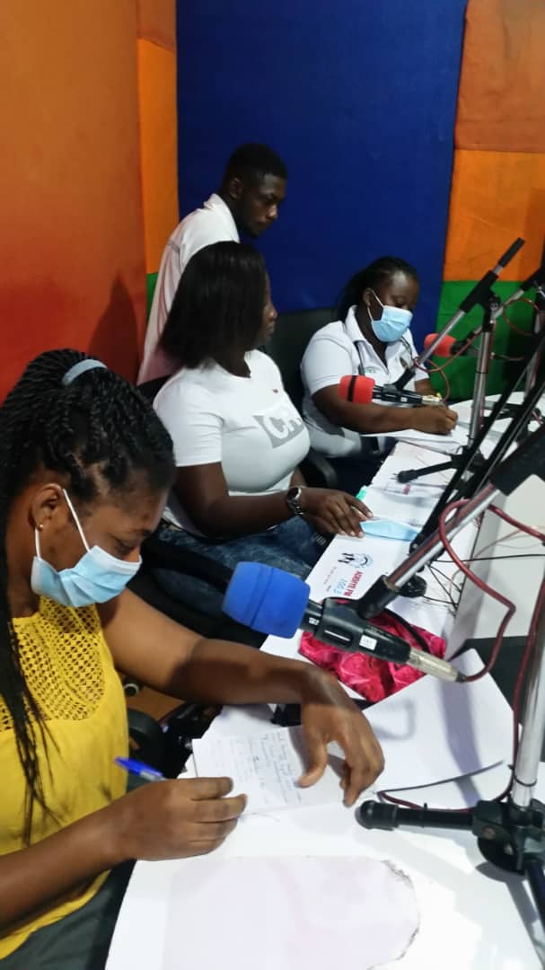
RADIO TALK SHOW PROGRAM WITH A LOCAL FM STATION (ADEHYE FM STATION)
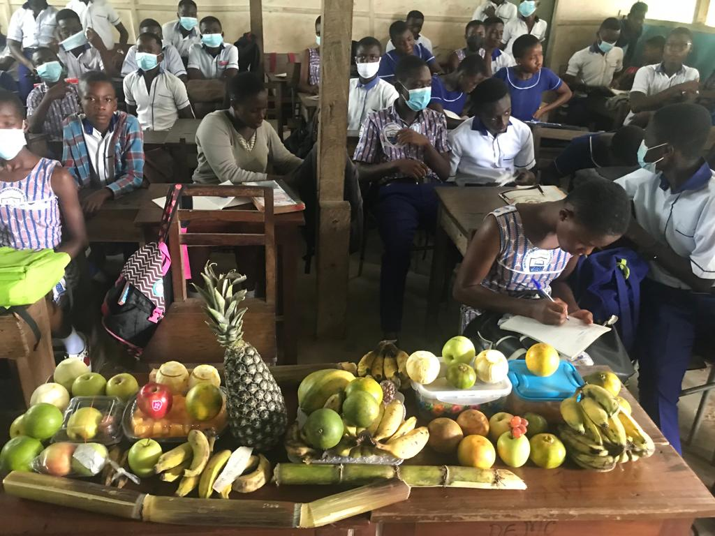
NUTRITION FRIENDLY SCHOOL INITIATIVE – FRUIT DAY AT SCHOOL
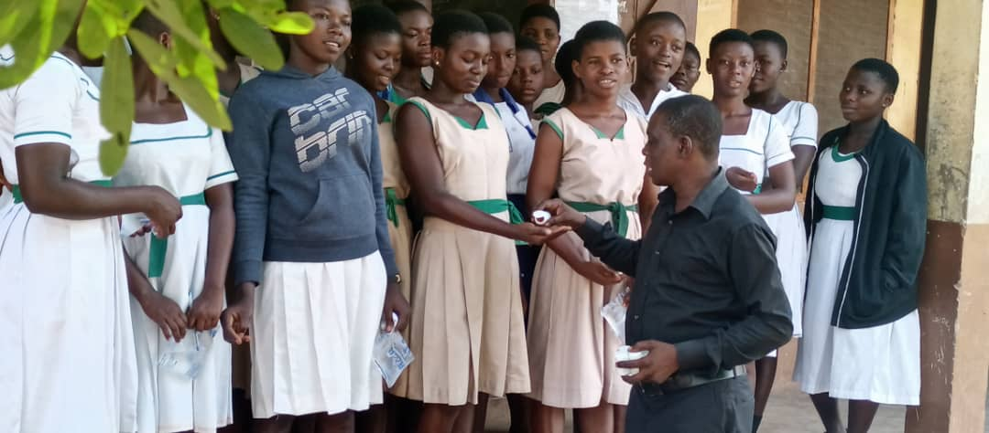
GIRLS IRON FOLATE TABLET SUPPLEMENTATION (GIFTS) – IN SCHOOL GIFTS
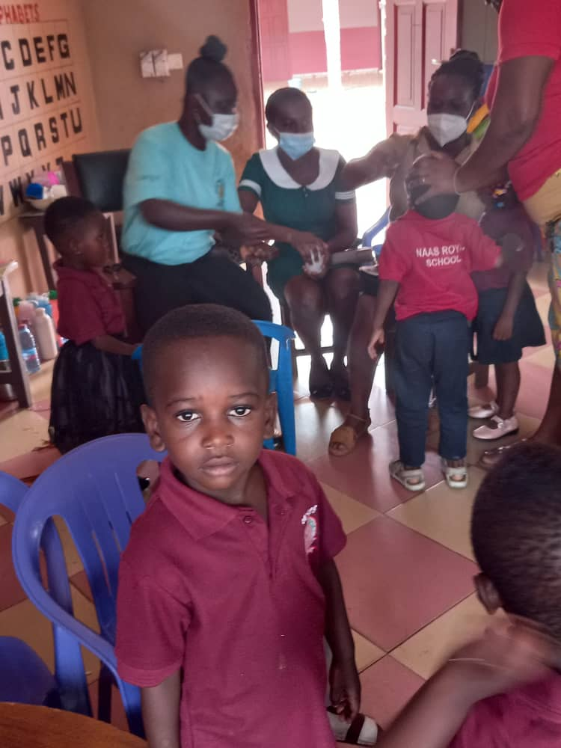
SCHOOL HEALTH AND SCREENING SERVICE
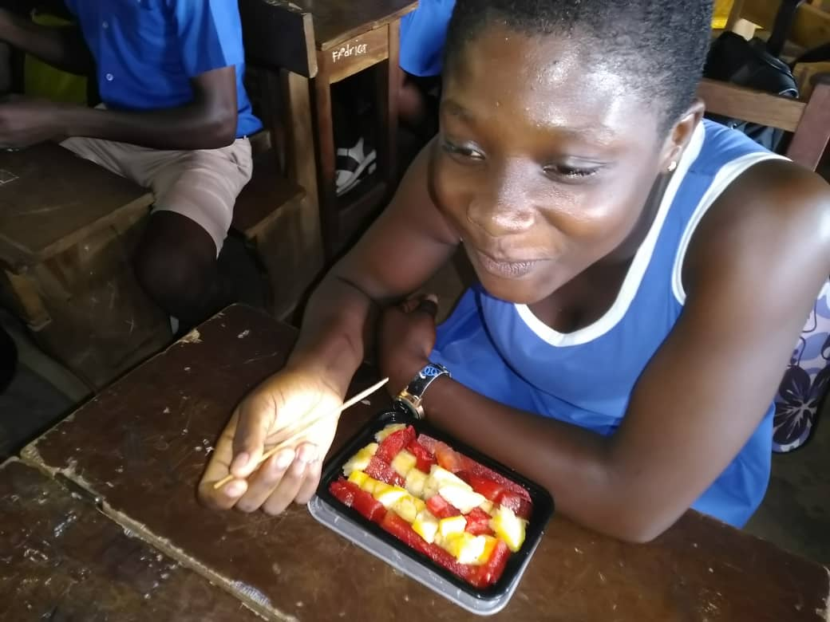
FRUIT DAY AT SCHOOL – NUTRITION FRIENDLY SCHOOL INITIATIVE

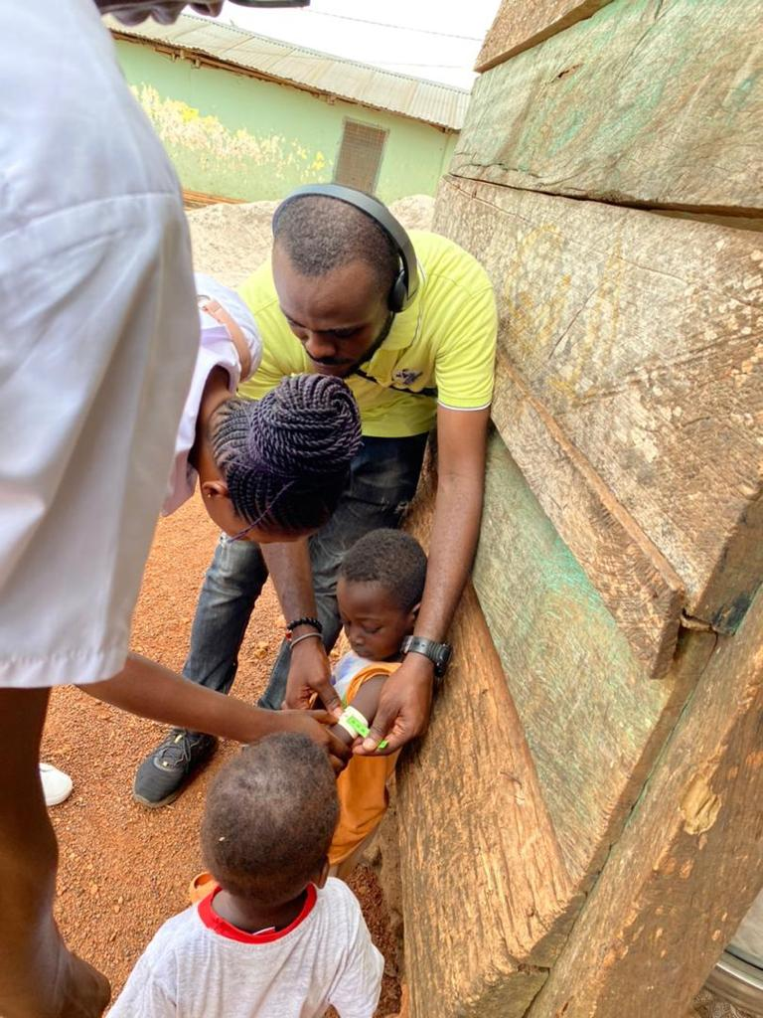
NURSES CARRYING OUT HOME VISITS AND SCREENING OF CHILDREN TO ASSESS THEIR NUTRITION STATUS
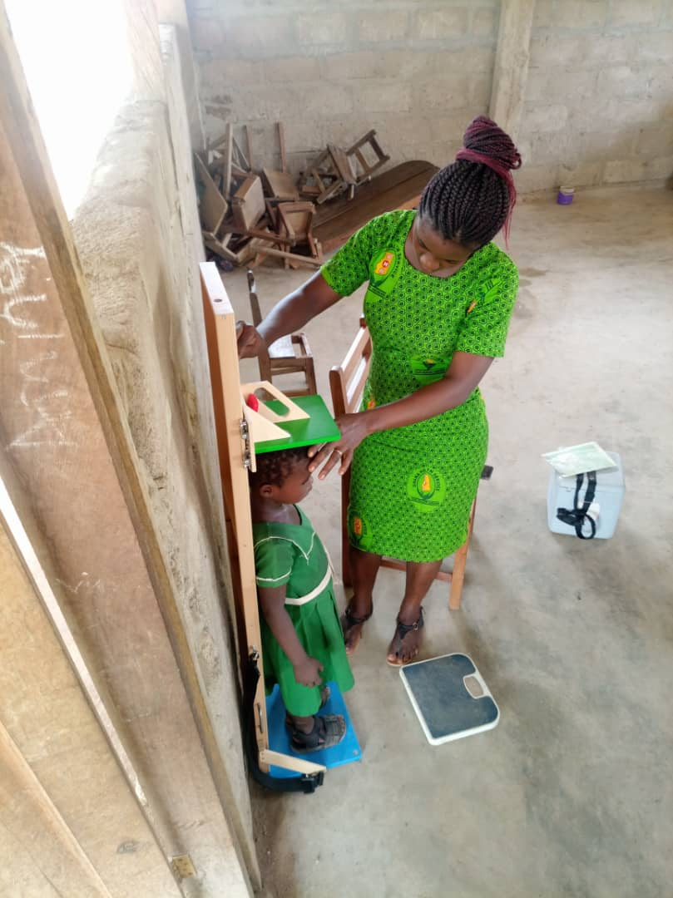
SCHOOL HEALTH – ASSESSING HEIGHT/LENGTH OF SCHOOL CHILDREN
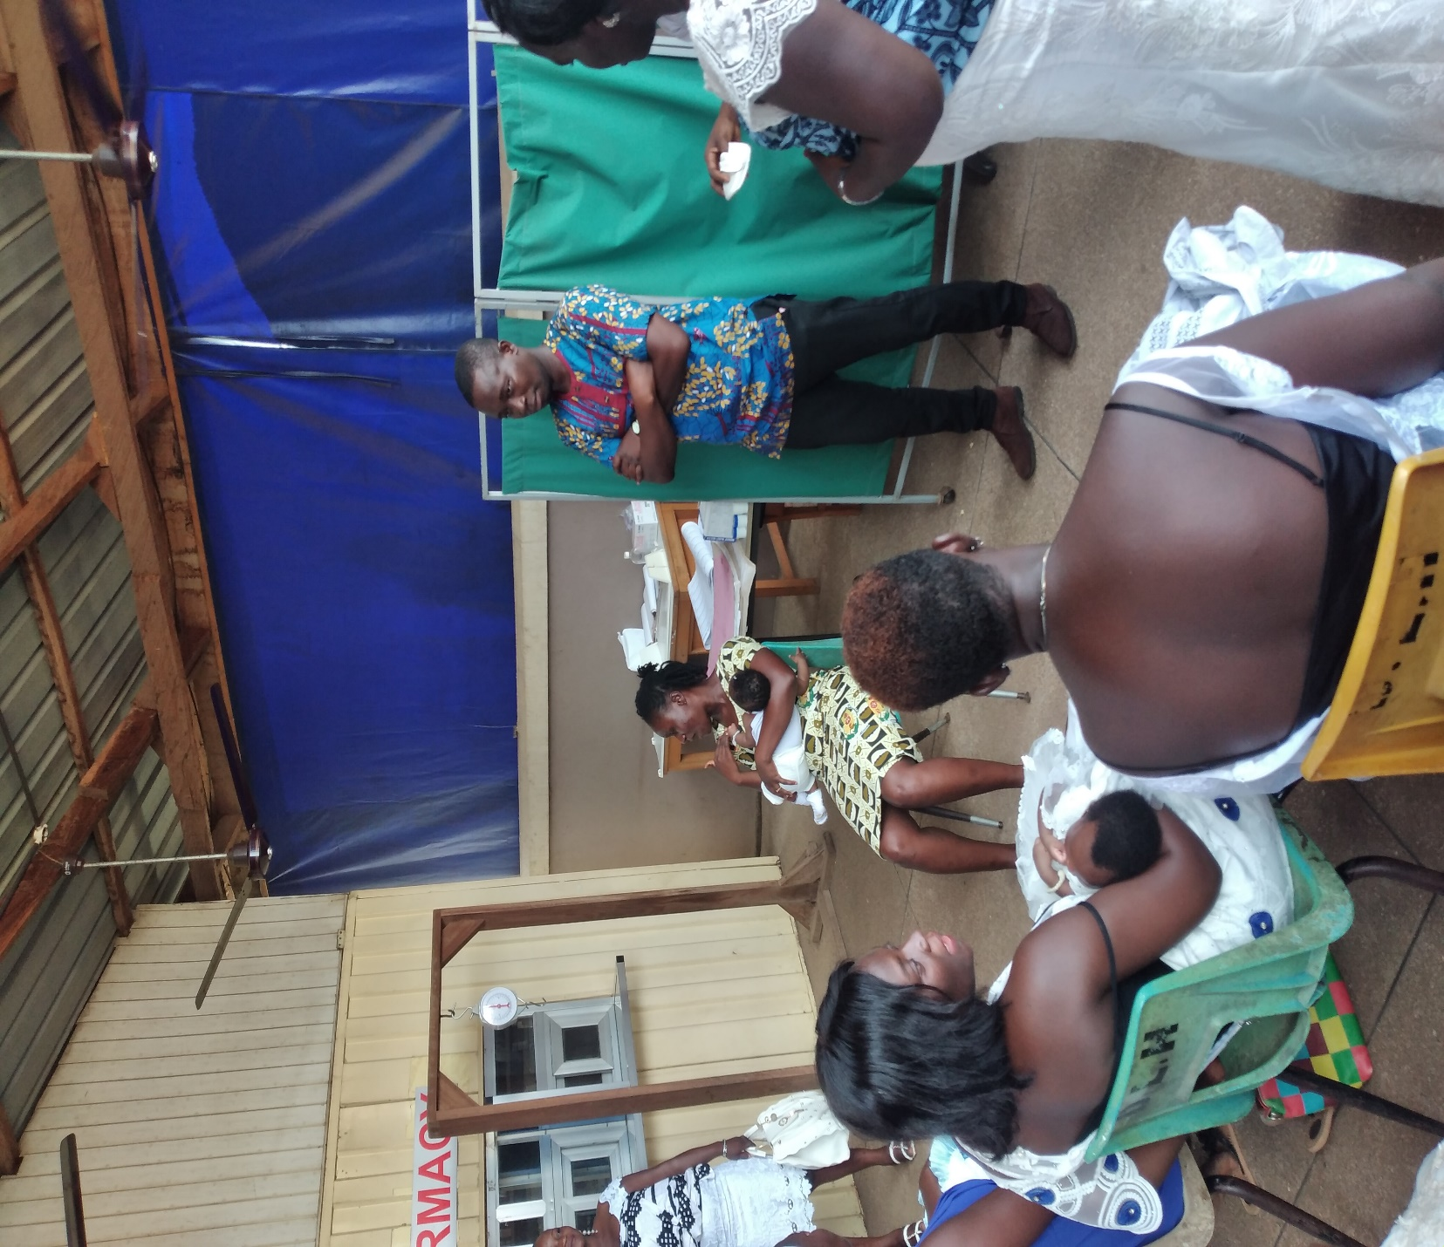
CHILD WELFARE CLINIC (CWC) – EDUCATING LACTATING MOTHERS ON HOW TO POSITION CHILDREN TO BREASTFEED PROPERLY

