FAMILY TRIBUNALS
Reporting period…… JANUARY- DECEMBER, 2021

Region/Location…WESTERN NORTH REGION

District………BIBIANI AHWIAWSO BEKWAI

Parties/Ref.No | Type of Case  (1 – 4) | Status of case  (1 – 3) | No. of children involved | Parental status  (1 – 4) | Parent education  (1 – 4) | Mother’s  Employment  (1 – 3) | Father’s  Employment  (1 – 3) | Place of Residence  (Location)
ADWOA ASANTEWAA  VRS COSMOS OSEI | FAMILY WELFARE | 1 | 1 | 1 | 1 | 1 | 3 | CHIRANO
ERIC GYAU  VRS PAULINA ANIMWAA | FAMILY WELFARE | 1 | 5 | 2 | 1 | 1 | 3 | SEFWI BEKWAI
ESTHER EDEM  VRS DANSO JOSEPH | FAMILY WELFARE | 1 | 2 | 1 | 1 | 1 | 3 | SEFWI BEKWAI
ADWOA ASANTEWAA VRS KWAME AGYAPONG | CHILD CUSTODY | 1 | 1 | 2 | 1 | 1 | 3 | CHIRANO
AISHATU ADAMA VRS SALIFU MUMUNI | FAMILY WELFARE | 1 | 1 | 2 | 1 | 1 | 3 | ABOABO
KWASI ALFRED VRS YAA ARMAH | CHILD MAINTENANCE | 1 | 1 | 2 | 1 | 1 | 3 | CHIRANO
OSMAN SEIDU VRS GLADYS INNUSAH | CHILD CUSTODY | 1 | 1 | 1 | 1 | 1 | 2 | OLD TOWN
JOSEPH MENSAH VRS AUGUSTINA SAM | CHILD CUSTODY | 1 | 1 | 2 | 1 | 1 | 3 | OLD COMPOUND
MARY NTORI VRS GABRIEL ANTWI | FAMILY WELFARE | 1 | 1 | 1 | 1 | 1 | 3 | DEGEDE
ERIC GYAN VRS ANIWAA PAULINA | FAMILY WELFARE | 1 | 5 | 2 | 1 | 1 | 3 | SEFWI BEKWAI
EDWARD ACKAH VRS JANET AMOAH | CHILD CUSTODY | 1 | 1 | 2 | 1 | 1 | 3 | GYEDI,BIBIANI
DORIS ANNOR VRS MARY KUBI | FAMILY WELFARE | 1 | 1 | 2 | 1 | 1 | 3 | BEKWAI
PAULINA AYENSU VRS KOJO ADIYA | FAMILY WELFARE | 1 | 1 | 2 | 1 | 1 | 3 | OLD COMPOUND
J.K ADDO VRS NTI ROSEMARY | FAMILY WELFARE | 1 | 1 | 1 | 1 | 1 | 3 | DEGEDE
During the year under review, fourteen cases were reported to the department for settlement, out of which nine (9) representing 64.3% were family welfare cases, one(1) was child maintenance also representing 7.1% and another four (4) representing 28.6% were also child custody cases. All of these cases were settled amicably.

CHILD RIGHTS PROMOTION AND PROTECTION
SOCIAL WORK WITH FAMILIES

Name of Child/Ref No. | Type of Activities  1-16 | Sex  (1-2) | Age  (1-3) | L0CATION | New Case  (1,0) | Status of Charge  (1-4)
JUSTICE OWUSU | STEALING | 1 | 2 | BIBIANI | 1 | pending
SOLOMON AMPOFO | STEALING | 1 | 3 | BIBIANI | 1 | 1
BRIGHT AFFUL | DEFILEMENT | 1 | 3 | BIBIANI | 1 | 1
EMMANUEL TAWIAH | DEFILEMENT | 1 | 3 | MUOHO | 1 | 1
RICHARD ACKAH | UNLAWFUL ENTRY AND STEALING | 1 | 3 | AFAMU | 1 | 1
ESTHER AMANO | DEFILEMENT | 2 | 3 | BIBIANI | 1 | 1
The year under review saw, six cases of social work with families been recorded. One involving justice Owusu is pending but the remaining cases have been settled.
COMMUNITY CARE
REGISTRATION OF PERSONS WITH DISABILITY
Reporting Period…JANUARY- DECEMBER, 2021
Region/Location…WESTERN NORTH REGION
District……BIBIANI AHWIAWSO BEKWAI MUNICIPALITY

NAME/REF NO. | CONTACT | AGE  (1-7) | SEX  (1-2) | EDUC.  BACKGROUND  (1-9) | TYPE OF  DISABILITY  (1-10) | EMPLOYMENT  (1-Yes,0-No) | TYPE OF TRADE ENGAGED  (1-17) | ORGANISATION  (1-7) | NHIS  (1-Yes,0-No) | SOURCE OF ASSISTANCE  (1-5) | NEED ASSESSMENT
KOFI AMANKWAA | 0242391404 | 5 | 1 | 1 | MOVING DIFFICULTY | 0 | 1 | 1 | 1 | 5 | 3
THEODORA ADDAE GYASI | 0593469495 | 1 | 2 | 1 | MOVING DIFFICULTY | 0 | 1 | 1 | 1 | 4 | 3
ABENA MANSAH | 0240108114 | 6 | 2 | - | MOVING DIFFICULTY | 0 | 1 | 1 | 1 | 4 | 3
ADJEI JOSEPH | 0246315276 | 7 | 1 | 1 | MOVING DIFFICULTY | 1 | TEACHER | 1 | 1 | 4 | 3
EMMANUEL OPOKU | 0246294889 | 7 | 1 | 4 | SEEING DIFFICULTY | 1 | RECORD KEEPING | 3 | 1 | 4 | 3
DANIEL KOFI NYAME ADDAE | 0544801951 | 3 | 1 | 2 | DOWN SYNDROME | 0 | - | 1 | 1 | 4 | 3
PATRICIA GYAM | 0548350889 | 2 | 2 | 1 | MOVING DIFFICULTY | 0 | - | 1 | 1 | 4 | 3
SAMUEL AZANGO OBENG | 0244079335 | 4 | 1 | 1 | DOWN SYNDROME | 0 | - | 1 | 1 | 3 | 2
RICHARD MENSAH SARBAH | 0244413999 | 7 | 1 | 1 | MOVING DIFFICULTY | 0 | - | 1 | 1 | 4 | 3
ELIZABETH MIREKU | 0244844433 | 2 | 1 | 3 | MOVING DIFFICULTY | 0 | 1 | 1 | 1 | 4 | 3
BEATRICE MENSAH SABAH | 0244413999 | 2 | 2 | 1 | MOVING DIFFICULTY | 0 | 1 | 1 | 1 | 4 | 3
MIREKU ELIZABETH | 0244844453 | 3 | 2 | 1 | MOVING DIFFICULTY | 0 | 1 | 1 | 1 | 4 | 3
GRACE OSEI | 0249762110 | 2 | 2 | - | SEEING DIFFICULTY | 1 | - | 3 | 1 | 4 | 3
MARUFF ISIFU HARUNA |  | 1 | 1 | 1 | SEEING DIFFICULTY | 0 | 1 | 3 | 1 | 4 | 3
ALBERT NSIAH | 0552652329 | 7 | 1 | 1 | MOVING DIFFICULTY | 0 | 1 | 3 | 1 | 4 | 3
SAMPSON ADU | 0555134299 | 2 | 1 | 1 | DOWN SYNDROME | 1 | 1 | 1 | 1 | 4 | 3
YAW ANAAFI | 0548350889 | 7 | 1 | 1 | MOVING DIFFICULTY | 0 | 1 | 3 | 1 | 3 | 1
ALHAJI MAHAMA | 0556632666 | 7 | 1 | 1 | SEEING DIFFICULTY | 1 | 1 | 3 | 1 | 3 | 1
RUKAYA ADAMA | 0595501014 | 7 | 2 | 1 | MOVING DIFFICULTY | 0 | 1 | 3 | 3 | 3 | 1
Within the year under review, nineteen (19) persons with disabilities were registered. Twelve (12) out of the nineteen (19) , which represent 63.1 % registered were physically challenged, four (4) was seeing difficulty and it also represent 21.1% and the other three (3) which represents 15.8% had Down syndrome.

HOSPITAL WELFARE SERVICES
Reporting period……JANUARY- DECEMBER, 2021

Region/Location……WESTERN NORTH REGION

District……………BIBIANI AHWIAWSO BEKWAI MUNICIPALITY

Name /Ref No. | Type of Cases  1-7 | Contact | Sex  (1-2) | Age  (1-6) | New Case  (1,0) | Mother’s  Employment  1-3 | Father’s  Employment  1-3 | Place of Residence | Status of Case
RUTH ADWOA MENSAH | 1 | - | 2 | 5 | 1 | 1 | - | KUMKUMSU | 1
TIJAANI MAMUNATU | 1 | - | 2 | 5 | 1 | 1 | - | MMEREWA | 1
ESTHER AMANO | 1 | - | 2 | 4 | 1 | 1 | - | BIBIANI | 1
During the year under review, three persons were taking to the hospital for treatment after they were proven to be paupers.
NGO
Reporting period …JANUARY- DECEMBER, 2021

Region/Location… WESTERN NORTH REGION

District………………BIBIANI AHWIAWSO BEKWAI

Total number of NGO’s in reporting period with their specialties……4

NAME/REF OF NGO | NAME OF OWNER | LOCATION | CONTACT | TYPE OF NGO  (1 – 5) | Thematic Area | New Registration  (1, 0) | STATUS OF REG. on time of reporting  (1 – 3) | STATUS OF RENEWAL on time of reporting  (1 – 3)
GHANA HEALTH AND EDUCATION INITIATIVE | CLEMENT DONKOR | HUMJIBRE | 0244060916 | 3 | HEALTH AND EDUCATION PROGRAMMES | 0 | 1 | 1
CONSERVATION FOUNDATION | ENOCH ASSUAH | BIBIANI | 0243105952 | 5 | HIV AIDS ,HEALTH INITIATIVES | 0 | 1 | -
NETWORK FOR HEALTH AND RELIEF FOUNDATION | ORACCA TETTEH | BIBIANI | 0556959213 | 5 | HEALTH INITIATIVES,GENDER ISSUES AND GOVERNANCE | 0 | 1 | 1
ORGANISATION FOR LIVELIHOOD EHANCEMENT SERVICES | MOSES OGOE | BIBIANI | 0501334290 | 2 | GENDER ISSUES AND GOVERNANCE | 0 | 3 | -
During the quarter under review, only two NGOs had renewed their registration with the department and the Assembly

DEPARTMENT OF COMMUNITY DEVELOPMENT
BIBIANI AHWIAWSO BEKWAI
ANNUAL REPORT JANUARY -DECEMBER, 2021
INTRODUCTION
The Department of Community Development exists to facilitate the mobilization and use of available human and material resources to improve upon the living condition of deprived rural and urban communities within an effectively decentralized system of administration through adult education, extension services and self-help projects .It is in this direction that the annual report is prepared.
The report however gives account of the activities, which were undertaken, in the Municipality during the year, 2021.
ORGANISATIONAL DETAILS:
Total number of staff on payroll 7
Actual number of staff at post 7
Postings or transfers 2
Total number of staff on study leave with pays Nil
Total number of staff on study leave without pays Nil
New appointments Nil
Number of courses or workshops organized nil
Number of courses or workshops attended 4

ADULT EDUCATION
The Department sensitized members of the Federation of Persons with Disabilities during their celebration on Worlds day against Disability on 8th December,2021 and issues discussed included access to police services, access to justice and the current state of the National Disability law. The social welfare and community Development officer took the opportunity to high light issues affecting disables such as parental neglect, discrimination, school dropout etc and advised them to remain focused and report any act that goes against their rights to the department.
CHILD LABOUR
In the fourth quarter, the Department through the support of JICA/GRADA sensitized and formed Community Child Protection Committee in ten (10) endemic communities within the Municipality.
The Department through the support of CARE INTERNATIONAL helped sensitized, formed and trained fifteen (15) Community Child Protection Committees in areas such as kojina B, Mframakrom, Kofikrom, debiso, Morno etc to help curb child labour menace in those areas.
INTEGRATED SOCIAL SERVICE DELIVERY (ISSD)
The Department through the Integrated Social Service Delivery (ISSD) under the UNICEF programme sensitized and formed forty (40) community child protection committes. This was done using the flash cards, Maize plant, ladder, balloon game and cycle of support to educate the masses. Some of the communities are listed as follows: Abokyikrom, Ahyiam, Alata, Mframayo, Abesioum, Awaso, Sukusuku, Nzemankwanta, Donkotolineso, Kwaaso, Adamakrom etc.
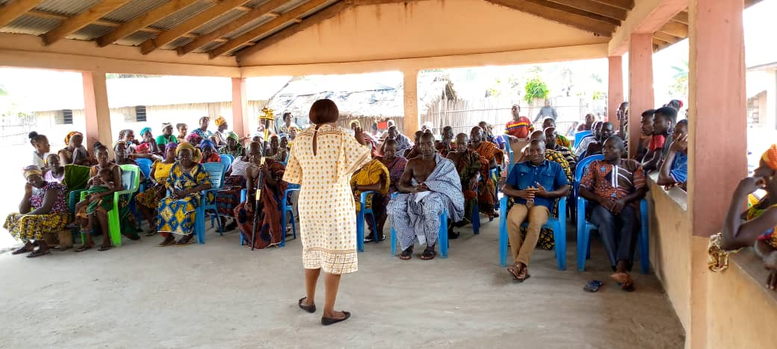Integrated service delivery speech.

CHILD RIGHTS AND PROTECTION PROMOTION
During the year under review, the department organized a radio programme on the 5th -6th July, 2021 on child rights and protection issues, issues discussed were on the children’s act of 1998, where it is enshrine that all children of school going age must be in school and parental duties towards their children. The following rights were expounded: right to parental property, rights to education and the right of the disabled child.
GENDER –BASED VIOLENCE
The department in collaboration with NCCE and DOVVSU sensitized five communities on sexual and gender based violence affecting children using child protection toolkits such as cycle of support and flash cards. The communities were as follows: Morno, Debiso, Alata, Kofikrom and Awaso.
HIV/AIDS
Under the year in review, the department also celebrated World’s Aids day at Bekwai on the 1st of December, 2021 and used the occasion to educate community members, students and the general public on the need to practice abstinence and use of condom to prevent unwanted pregnancies among teenagers. The audience were given chance to ask question and further clarification were given by the representative of the Ghana Health service (Samuel Ansah). Community members were taking through testing and some came out positive.
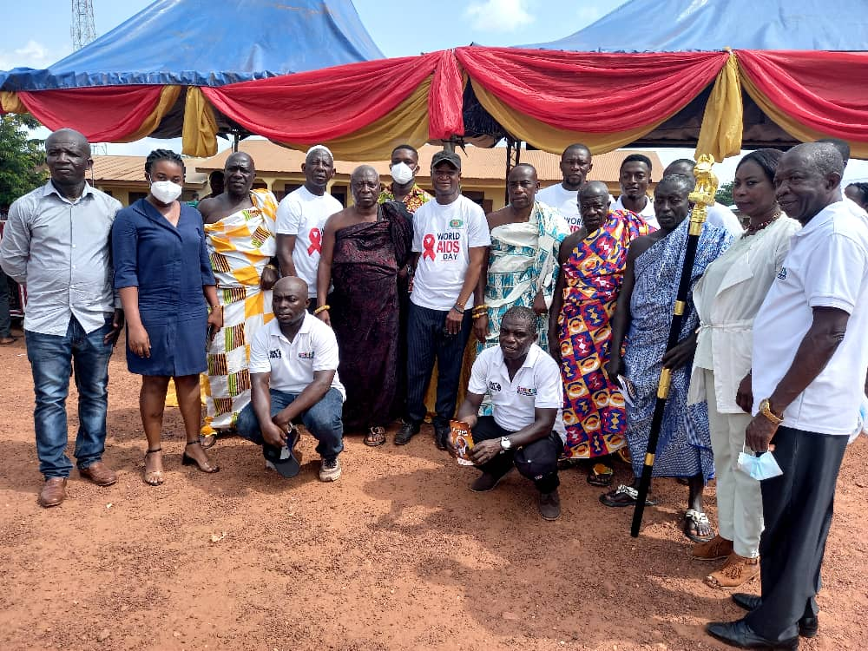WORLD’S AIDS DAYS

SELF HELP PROJECTS
The department through the District Assembly Common fund allocations to Persons with Disability (PWD) supported the following persons with cash and items during the first quarter of 2021.
S/N | TYPE OF ITEM | QUANTITY
 | Deep freezers | 10
 | Fufu machine | 2
 | Assorted items | 2
 | Wheelchair | 65
 | Educational support | 12
 | Medical support | 2
 | Industrial machine | 1
 | Total | 94

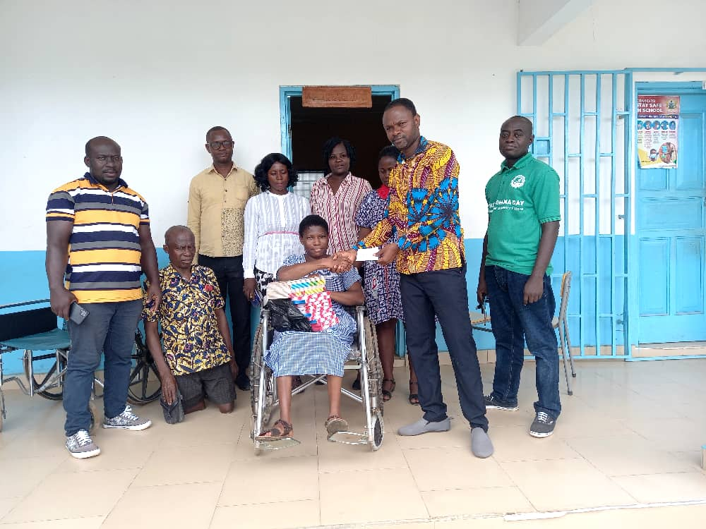Donation of PWD at queen’s SHS

INCOME GENERATING ACTIVITIES
The department in collaboration with CARE INTERNATIONAL organized and trained three hundred and twenty (320) women in soap production making and para zone production .Also eighty (80) young girls are also currently learning apprenticeship and are at various stages of completion.
FOOD AND NUTRITION
The Department in collaboration with Ghana Health Service (Nutrition Unit) and Environmental Health unit trained food vendors/caterers of the Ghana School feeding programme on proper food nutrition to be giving to the pupils. The Food and Nutrition officer, Linda Opoku Danso gave samples of nutritious foods and vegetables as fruits, grains and cereals that are to be giving. She further stressed that, good nutrition gives good health and proper functioning of the body and increases the brain power of the pupils. The meeting took place on 15th and 16th April, 2021.
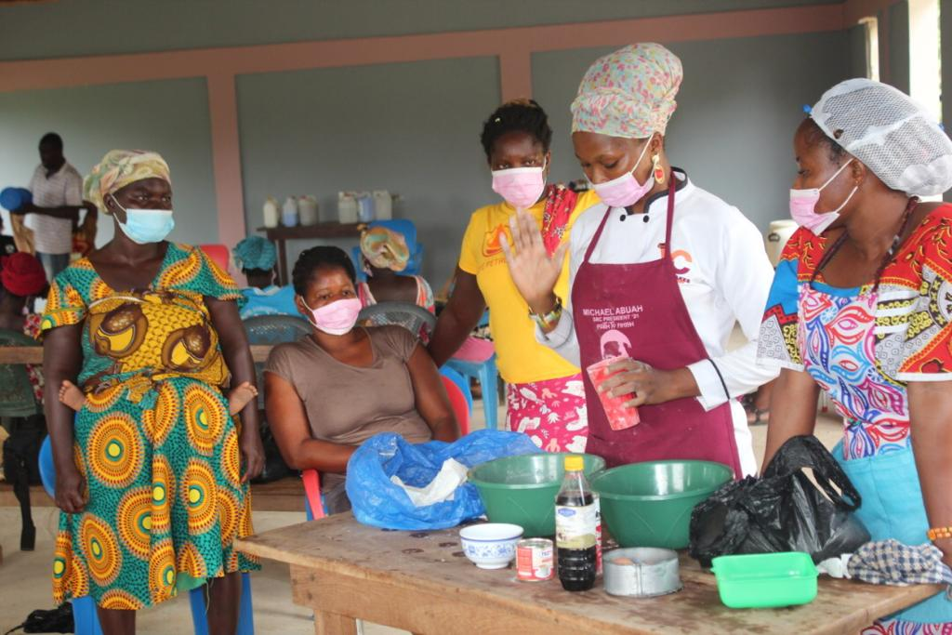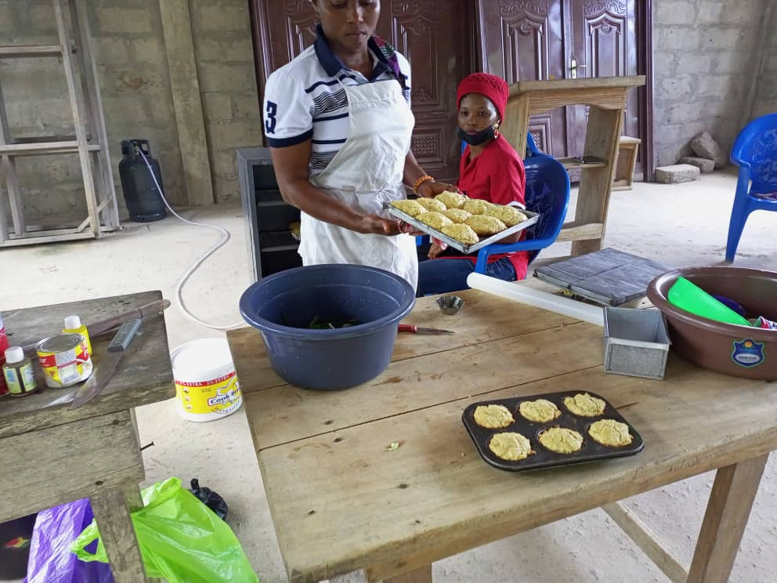

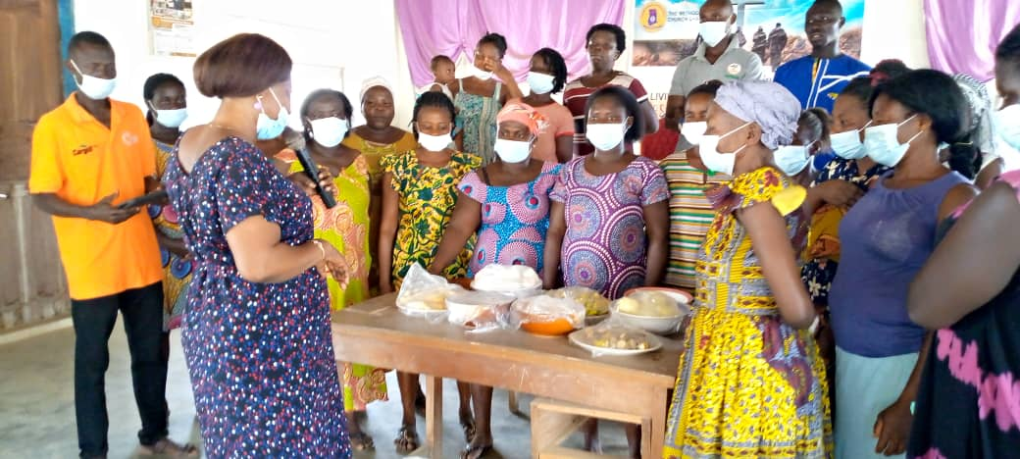

PRODUCTIVE INCLUSION INITIATIVE PROGRAMME/APPRENTICESHIP
To help improve the living condition of the vulnerable, the department under the European union sponsored programme (Productive inclusion (PI) selected and is training sixteen persons (16) ie twelve (12) persons who are intellectually able and four ( 4) disabled in various skill acquisition at Tarkwa ,Kumasi KTI, Mankessim, Takoradi etc .They are undergoing training in dump truck operating, auto mechanic, soap and cosmetic production, solar energy etc. the sixteen(16) persons will be giving start up kits after completion of the programmed.
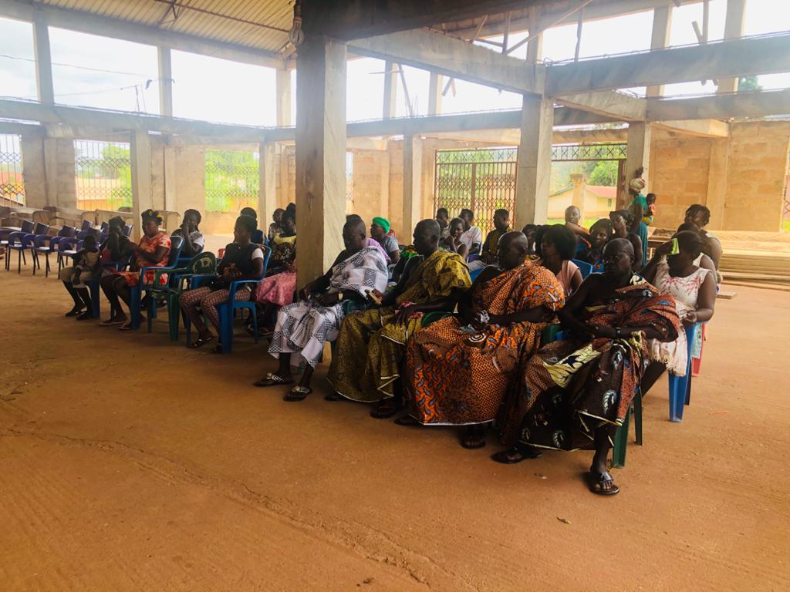
Initiative Programme.

NATIONAL HEALTH INSURANCE SCHEME REGISTRATION
During the year under review, seven hundred and sixty –three (763) persons belonging to the indigent (persons with Disabilities) group were registered onto the National Health Insurance scheme. In all ten communities were engaged in this exercise.
RESIDENTIAL HOME OPERATION
The Department of Social Welfare and Community Development is currently operating one residential home within the municipality with a GPS address number YB -0009-3014 and is been cared for by Miss Charlotte Abrafi a Social Worker of the department . The Department received eight (8) missing children and were reunited with their families.
HOTLINE NUMBERS
The Department of Social Welfare and Community Development has a dedicated hotline in which citizens can call for inquiries and the numbers are as follows: 0502494929, 0244851924, via email mensahellis1986@gmail.com

LEAP BENEFICIARIES
During the year under review, LEAP beneficiaries comprising one thousand, one hundred and seventy (1,170) households were credited with funds from the LEAP Secretariat. The total amount received for the six payment cycles ie 64th -65th ,67th- 68th ,69th -70th payment cycle amounted to Five Hundred and fifty-nine thousand, three hundred and thirty-two Ghana cedis (Gh₵559,332.00).
GHANA SCHOOL FEEDING PROGRAMME (GSFP)
There are currently ninety-three (93) schools benefiting from the School Feeding Programme (GSFP) within the municipality and eighty –nine (89) caterers.
Ninety-three (93) public primary schools (KG 1 to class 6) benefited from the programme for the period 20th June to 14th September, 2021.
One Hundred and fourteen (114) schools benefited from the JHS 3 feeding programme for one month (24th August 2021 to 20th September 2021). It was made up of Seventy-two (72) public and Forty-two (42) private schools.
One Hundred and nineteen (119) schools also benefited from the JHS 2 feeding programme for the period (30th June, 2021 to 30th September, 2021). It was made up of Seventy-four (74) public and Forty-five (45) private schools.
The total enrolment for the School Feeding Programme is Twenty Six thousand, eight hundred and sixty-three (26,863)
REFFERRALS
The year under review saw ten (10) referrals been made from the department to the National Health Insurance scheme and to the court.
CHALLENGES
1. Bad road network also affects work tremendously
2. Inadequate funds for field work as commuting to the communities is very costly because of bad roads
3. No motivation from the Department
It is our hope that more could be achieved next quarter if all necessary tools are provided for effective and efficient wok.

